






Prepare and produce cakes and pastries
D1.HPA.CL4.08
Trainer Guide

Prepare and produce cakes and pastries

D1.HPA.CL4.08

Trainer Guide




Project Base
William Angliss Institute of TAFE
555 La Trobe Street
Melbourne 3000 Victoria
Telephone: | (03) 9606 2111
Facsimile: | (03) 9670 1330
Acknowledgements
Project Director: | Wayne Crosbie
Chief Writer: | Alan Hickman
Subject Writer: | Garry Blackburn
Project Manager: | Alan Maguire
Editor: | Jim Irwin
DTP/Production: | Daniel Chee, Mai Vu, Jirayu Thangcharoensamut, Kaly Quach

The Association of Southeast Asian Nations (ASEAN) was established on 8 August 1967. The Member The Association of Southeast Asian Nations (ASEAN) was established on 8 August 1967. The Member States of the Association are Brunei Darussalam, Cambodia, Indonesia, Lao PDR, Malaysia, Myanmar, Philippines, Singapore, Thailand and Viet Nam.
The ASEAN Secretariat is based in Jakarta, Indonesia.
General Information on ASEAN appears online at the ASEAN Website: www.asean.org.
All text is produced by William Angliss Institute of TAFE for the ASEAN Project on “Toolbox Development for Front Office, Food and Beverage Services and Food Production Divisions”.
This publication is supported by the Australian Government’s aid program through the ASEAN-Australia Development Cooperation Program Phase II (AADCP II).
Copyright: Association of Southeast Asian Nations (ASEAN) 2013.
All rights reserved.
Disclaimer
Every effort has been made to ensure that this publication is free from errors or omissions. However, you should conduct your own enquiries and seek professional advice before relying on any fact, statement or matter contained in this book. The ASEAN Secretariat and William Angliss Institute of TAFE are not responsible for any injury, loss or damage as a result of material included or omitted from this course. Information in this module is current at the time of publication. Time of publication is indicated in the date stamp at the bottom of each page.
Some images appearing in this resource have been purchased from stock photography suppliers Shutterstock and iStockphoto and other third party copyright owners and as such are non-transferable and non-exclusive. Clip arts, font images and illustrations used are from the Microsoft Office Clip Art and Media Library. Some images have been provided by and are the property of William Angliss Institute.
Additional images have been sourced from Flickr and SKC and are used under Creative Commons licence: http://creativecommons.org/licenses/by/2.0/deed.en
File name: TG_Prepare_&_produce_cakes_&_pastries_FN_060214





Table of contents
Competency Based Training (CBT) and assessment - An introduction for trainers 1
Competency standard 11
Notes and PowerPoint slides 21
Recommended training equipment 67
Instructions for Trainers for using PowerPoint – Presenter View 69
Appendix – ASEAN acronyms 71

Competency Based Training (CBT) and assessment - An introduction for trainers

Competency
Competency refers to the ability to perform particular tasks and duties to the standard of performance expected in the workplace.
Competency requires the application of specified knowledge, skills and attitudes relevant to effective participation, consistently over time and in the workplace environment.
The essential skills and knowledge are either identified separately or combined.
Knowledge identifies what a person needs to know to perform the work in an informed and effective manner.
Skills describe the application of knowledge to situations where understanding is converted into a workplace outcome.
Attitude describes the founding reasons behind the need for certain knowledge or why skills are performed in a specified manner.
Competency covers all aspects of workplace performance and involves:
- Performing individual tasks
- Managing a range of different tasks
- Responding to contingencies or breakdowns
- Dealing with the responsibilities of the workplace
- Working with others.

Unit of Competency
Like with any training qualification or program, a range of subject topics are identified that focus on the ability in a certain work area, responsibility or function.
Each manual focuses on a specific unit of competency that applies in the hospitality workplace.
In this manual a unit of competency is identified as a ‘unit’.
Each unit of competency identifies a discrete workplace requirement and includes:
- Knowledge and skills that underpin competency
- Language, literacy and numeracy
- Occupational health and safety requirements.
Each unit of competency must be adhered to in training and assessment to ensure consistency of outcomes.

Element of Competency
An element of competency describes the essential outcomes within a unit of competency.
The elements of competency are the basic building blocks of the unit of competency. They describe in terms of outcomes the significant functions and tasks that make up the competency.
In this manual elements of competency are identified as an ‘element’.

Performance criteria
Performance criteria indicate the standard of performance that is required to demonstrate achievement within an element of competency. The standards reflect identified industry skill needs.
Performance criteria will be made up of certain specified skills, knowledge and attitudes.

Learning
For the purpose of this manual learning incorporates two key activities:
- Training
- Assessment.
Both of these activities will be discussed in detail in this introduction.
Today training and assessment can be delivered in a variety of ways. It may be provided to participants:
- On-the-job – in the workplace
- Off-the-job – at an educational institution or dedicated training environment
- As a combination of these two options.
No longer is it necessary for learners to be absent from the workplace for long periods of time in order to obtain recognised and accredited qualifications.

Learning Approaches
This manual will identify two avenues to facilitate learning:
Competency Based Training (CBT)
This is the strategy of developing a participant’s competency.
Educational institutions utilise a range of training strategies to ensure that participants are able to gain the knowledge and skills required for successful:
- Completion of the training program or qualification
- Implementation in the workplace.
The strategies selected should be chosen based on suitability and the learning styles of participants.

Competency Based Assessment (CBA)
This is the strategy of assessing competency of a participant.
Educational institutions utilise a range of assessment strategies to ensure that participants are assessed in a manner that demonstrates validity, fairness, reliability, flexibility and fairness of assessment processes.

Flexibility in Learning
It is important to note that flexibility in training and assessment strategies is required to meet the needs of participants who may have learning difficulties. The strategies used will vary, taking into account the needs of individual participants with learning difficulties. However they will be applied in a manner which does not discriminate against the participant or the participant body as a whole.
Catering for Participant Diversity
Participants have diverse backgrounds, needs and interests. When planning training and assessment activities to cater for individual differences, trainers and assessors should:
- Consider individuals’ experiences, learning styles and interests
- Develop questions and activities that are aimed at different levels of ability
- Modify the expectations for some participants
- Provide opportunities for a variety of forms of participation, such as individual, pair and small group activities
- Assess participants based on individual progress and outcomes.
The diversity among participants also provides a good reason for building up a learning community in which participants support each other’s learning.
Participant Centred Learning
This involves taking into account structuring training and assessment that:
- Builds on strengths – Training environments need to demonstrate the many positive features of local participants (such as the attribution of academic success to effort, and the social nature of achievement motivation) and of their trainers (such as a strong emphasis on subject disciplines and moral responsibility). These strengths and uniqueness of local participants and trainers should be acknowledged and treasured
- Acknowledges prior knowledge and experience – The learning activities should be planned with participants’ prior knowledge and experience in mind
- Understands learning objectives – Each learning activity should have clear learning objectives and participants should be informed of them at the outset. Trainers should also be clear about the purpose of assignments and explain their significance to participants
- Teaches for understanding – The pedagogies chosen should aim at enabling participants to act and think flexibly with what they know
- Teaches for independent learning – Generic skills and reflection should be nurtured through learning activities in appropriate contexts of the curriculum. Participants should be encouraged to take responsibility for their own learning
- Enhances motivation – Learning is most effective when participants are motivated. Various strategies should be used to arouse the interest of participants
- Makes effective use of resources – A variety of teaching resources can be employed as tools for learning
- Maximises engagement – In conducting learning activities, it is important for the minds of participants to be actively engaged
- Aligns assessment with learning and teaching – Feedback and assessment should be an integral part of learning and teaching
- Caters for learner diversity – Trainers should be aware that participants have different characteristics and strengths and try to nurture these rather than impose a standard set of expectations.
Active Learning
The goal of nurturing independent learning in participants does not imply that they always have to work in isolation or solely in a classroom. On the contrary, the construction of knowledge in tourism and hospitality studies can often best be carried out in collaboration with others in the field. Sharing experiences, insights and views on issues of common concern, and working together to collect information through conducting investigative studies in the field (active learning) can contribute a lot to their eventual success.
Active learning has an important part to play in fostering a sense of community in the class. First, to operate successfully, a learning community requires an ethos of acceptance and a sense of trust among participants, and between them and their trainers. Trainers can help to foster acceptance and trust through encouragement and personal example, and by allowing participants to take risks as they explore and articulate their views, however immature these may appear to be. Participants also come to realise that their classmates (and their trainers) are partners in learning and solving.
Trainers can also encourage cooperative learning by designing appropriate group learning tasks, which include, for example, collecting background information, conducting small-scale surveys, or producing media presentations on certain issues and themes. Participants need to be reminded that, while they should work towards successful completion of the field tasks, developing positive peer relationships in the process is an important objective of all group work.

Competency Based Training (CBT)
Principle of Competency Based Training
Competency based training is aimed at developing the knowledge, skills and attitudes of participants, through a variety of training tools.
Training Strategies
The aims of this curriculum are to enable participants to:
- Undertake a variety of subject courses that are relevant to industry in the current environment
- Learn current industry skills, information and trends relevant to industry
- Learn through a range of practical and theoretical approaches
- Be able to identify, explore and solve issues in a productive manner
- Be able to become confident, equipped and flexible managers of the future
- Be ‘job ready’ and a valuable employee in the industry upon graduation of any qualification level.
To ensure participants are able to gain the knowledge and skills required to meet competency in each unit of competency in the qualification, a range of training delivery modes are used.
Types of Training
In choosing learning and teaching strategies, trainers should take into account the practical, complex and multi-disciplinary nature of the subject area, as well as their participant’s prior knowledge, learning styles and abilities.
Training outcomes can be attained by utilising one or more delivery methods:
Lecture/Tutorial
This is a common method of training involving transfer of information from the trainer to the participants. It is an effective approach to introduce new concepts or information to the learners and also to build upon the existing knowledge. The listener is expected to reflect on the subject and seek clarifications on the doubts.
Demonstration
Demonstration is a very effective training method that involves a trainer showing a participant how to perform a task or activity. Through a visual demonstration, trainers may also explain reasoning behind certain actions or provide supplementary information to help facilitate understanding.
Group Discussions
Brainstorming in which all the members in a group express their ideas, views and opinions on a given topic. It is a free flow and exchange of knowledge among the participants and the trainer. The discussion is carried out by the group on the basis of their own experience, perceptions and values. This will facilitate acquiring new knowledge. When everybody is expected to participate in the group discussion, even the introverted persons will also get stimulated and try to articulate their feelings.
The ideas that emerge in the discussions should be noted down and presentations are to be made by the groups. Sometimes consensus needs to be arrived at on a given topic. Group discussions are to be held under the moderation of a leader guided by the trainer. Group discussion technique triggers thinking process, encourages interactions and enhances communication skills.
Role Play
This is a common and very effective method of bringing into the classroom real life situations, which may not otherwise be possible. Participants are made to enact a particular role so as to give a real feel of the roles they may be called upon to play. This enables participants to understand the behaviour of others as well as their own emotions and feelings. The instructor must brief the role players on what is expected of them. The role player may either be given a ready-made script, which they can memorize and enact, or they may be required to develop their own scripts around a given situation. This technique is extremely useful in understanding creative selling techniques and human relations. It can be entertaining and energizing and it helps the reserved and less literate to express their feelings.

Simulation Games
When trainees need to become aware of something that they have not been conscious of, simulations can be a useful mechanism. Simulation games are a method based on "here and now" experience shared by all the participants. The games focus on the participation of the trainees and their willingness to share their ideas with others. A "near real life" situation is created providing an opportunity to which they apply themselves by adopting certain behaviour. They then experience the impact of their behaviour on the situation. It is carried out to generate responses and reactions based on the real feelings of the participants, which are subsequently analysed by the trainer.
While use of simulation games can result in very effective learning, it needs considerable trainer competence to analyse the situations.
Individual /Group Exercises
Exercises are often introduced to find out how much the participant has assimilated. This method involves imparting instructions to participants on a particular subject through use of written exercises. In the group exercises, the entire class is divided into small groups, and members are asked to collaborate to arrive at a consensus or solution to a problem.
Case Study
This is a training method that enables the trainer and the participant to experience a real life situation. It may be on account of events in the past or situations in the present, in which there may be one or more problems to be solved and decisions to be taken. The basic objective of a case study is to help participants diagnose, analyse and/or solve a particular problem and to make them internalize the critical inputs delivered in the training. Questions are generally given at the end of the case study to direct the participants and to stimulate their thinking towards possible solutions. Studies may be presented in written or verbal form.
Field Visit
This involves a carefully planned visit or tour to a place of learning or interest. The idea is to give first-hand knowledge by personal observation of field situations, and to relate theory with practice. The emphasis is on observing, exploring, asking questions and understanding. The trainer should remember to brief the participants about what they should observe and about the customs and norms that need to be respected.
Group Presentation
The participants are asked to work in groups and produce the results and findings of their group work to the members of another sub-group. By this method participants get a good picture of each other's views and perceptions on the topic and they are able to compare them with their own point of view. The pooling and sharing of findings enriches the discussion and learning process.
Practice Sessions
This method is of paramount importance for skills training. Participants are provided with an opportunity to practice in a controlled situation what they have learnt. It could be real life or through a make-believe situation.

Games
This is a group process and includes those methods that involve usually fun-based activity, aimed at conveying feelings and experiences, which are everyday in nature, and applying them within the game being played. A game has set rules and regulations, and may or may not include a competitive element. After the game is played, it is essential that the participants be debriefed and their lessons and experiences consolidated by the trainer.
Research
Trainers may require learners to undertake research activities, including online research, to gather information or further understanding about a specific subject area.

Competency Based Assessment (CBA)
Principle of Competency Based Assessment
Competency based assessment is aimed at compiling a list of evidence that shows that a person is competent in a particular unit of competency.
Competencies are gained through a multitude of ways including:
- Training and development programs
- Formal education
- Life experience
- Apprenticeships
- On-the-job experience
- Self-help programs.
All of these together contribute to job competence in a person. Ultimately, assessors and participants work together, through the ‘collection of evidence’ in determining overall competence.
This evidence can be collected:
- Using different formats
- Using different people
- Collected over a period of time.
The assessor who is ideally someone with considerable experience in the area being assessed, reviews the evidence and verifies the person as being competent or not.
Flexibility in Assessment
Whilst allocated assessment tools have been identified for this subject, all attempts are made to determine competency and suitable alternate assessment tools may be used, according to the requirements of the participant.
The assessment needs to be equitable for all participants, taking into account their cultural and linguistic needs.
Competency must be proven regardless of:
- Language
- Delivery Method
- Assessment Method.
Assessment Objectives
The assessment tools used for subjects are designed to determine competency against the ‘elements of competency’ and their associated ‘performance criteria’.
The assessment tools are used to identify sufficient:
- Knowledge, including underpinning knowledge
- Skills
- Attitudes
Assessment tools are activities that trainees are required to undertake to prove participant competency in this subject.
All assessments must be completed satisfactorily for participants to obtain competence in this subject. There are no exceptions to this requirement, however, it is possible that in some cases several assessment items may be combined and assessed together.
Types of Assessment
Allocated Assessment Tools
There are a number of assessment tools that are used to determine competency in this subject:
- Work projects
- Written questions
- Oral questions
- Third Party Report
- Observation Checklist.
Instructions on how assessors should conduct these assessment methods are explained in the Assessment Manuals.
Alternative Assessment Tools
Whilst this subject has identified assessment tools, as indicated above, this does not restrict the assessor from using different assessment methods to measure the competency of a participant.
Evidence is simply proof that the assessor gathers to show participants can actually do what they are required to do.
Whilst there is a distinct requirement for participants to demonstrate competency, there are many and diverse sources of evidence available to the assessor.
Ongoing performance at work, as verified by a supervisor or physical evidence, can count towards assessment. Additionally, the assessor can talk to customers or work colleagues to gather evidence about performance.
A range of assessment methods to assess competency include:
- Practical demonstrations
- Practical demonstrations in simulated work conditions
- Problem solving
- Portfolios of evidence
- Critical incident reports
- Journals
- Oral presentations
- Interviews
- Videos
- Visuals: slides, audio tapes
- Case studies
- Log books
- Projects
- Role plays
- Group projects
- Group discussions
- Examinations.
Recognition of Prior Learning
Recognition of Prior Learning is the process that gives current industry professionals who do not have a formal qualification, the opportunity to benchmark their extensive skills and experience against the standards set out in each unit of competency/subject.
Also known as a Skills Recognition Audit (SRA), this process is a learning and assessment pathway which encompasses:
- Recognition of Current Competencies (RCC)
- Skills auditing
- Gap analysis and training
- Credit transfer.
Assessing competency
As mentioned, assessment is the process of identifying a participant’s current knowledge, skills and attitudes sets against all elements of competency within a unit of competency. Traditionally in education, grades or marks were given to participants, dependent on how many questions the participant successfully answered in an assessment tool.
Competency based assessment does not award grades, but simply identifies if the participant has the knowledge, skills and attitudes to undertake the required task to the specified standard.
Therefore, when assessing competency, an assessor has two possible results that can be awarded:
- Pass Competent (PC)
- Not Yet Competent (NYC).
Pass Competent (PC)
If the participant is able to successfully answer or demonstrate what is required, to the expected standards of the performance criteria, they will be deemed as ‘Pass Competent’ (PC).
The assessor will award a ‘Pass Competent’ (PC) if they feel the participant has the necessary knowledge, skills and attitudes in all assessment tasks for a unit.
Not Yet Competent’ (NYC)
If the participant is unable to answer or demonstrate competency to the desired standard, they will be deemed to be ‘Not Yet Competent’ (NYC).
This does not mean the participant will need to complete all the assessment tasks again. The focus will be on the specific assessment tasks that were not performed to the expected standards.
The participant may be required to:
a) Undertake further training or instruction
b) Undertake the assessment task again until they are deemed to be ‘Pass Competent’.

Competency standard
UNIT TITLE: PREPARE AND PRODUCE CAKES AND PASTRIES |  |  |  | NOMINAL HOURS: 30
UNIT NUMBER: D1.HPA.CL4.08
UNIT DESCRIPTOR: This unit deals with skills and knowledge required by cooks, chefs and patissiers to prepare, produce, display and store a range of high quality cakes and pastries in commercial food production environments
ELEMENTS AND PERFORMANCE CRITERIA | UNIT VARIABLE AND ASSESSMENT GUIDE
Element 1: Prepare and bake cakes and filings  - Select required commodities according to recipe and production requirements  - Prepare a variety of cakes to desired product characteristics  - Produce a variety of cakes according to standard recipes and enterprise standards  - Use appropriate equipment to prepare and bake cakes  - Use correct techniques to produce cakes to enterprise standards  - Bake cakes to enterprise requirements and standards  - Select correct oven conditions for baking cakes  Element 2: Decorate and present/display cakes  - Prepare a variety of fillings and coating/icing, glazes and decorations for cakes | Unit Variables  The Unit Variables provide advice to interpret the scope and context of this unit of competence, allowing for differences between enterprises and workplaces. It relates to the unit as a whole and facilitates holistic assessment  This unit applies to all industry sectors that are responsible for preparing, cooking, displaying and storing a range of cakes and pastries within the labour divisions of the hotel and travel industries and may include:  - Food Production.  Commodities may include:  Flours  Sugars  Fruits  Nuts  Eggs  Milk  Cream
- Decorate cakes using fillings and coating/icing and decorations according to standard recipes and/or enterprise standards and/or customer requests  - Present/display cakes to enterprise standards using appropriate service equipment  Element 3: Prepare and produce pastries and fillings  - Select required commodities according to recipe and production requirements  - Prepare a variety of pastries  - Produce a variety of pastries according to standard recipes and enterprise standards  - Use appropriate equipment to prepare and bake pastries  - Use correct techniques to produce pastries to enterprise standards  - Bake pastries to enterprise requirements and standards  - Select correct oven conditions for baking pastries  Element 4: Decorate and present pastries  - Prepare a variety of filings coating, icing, glazes and decorations for pastries | Gelatin  Flavourings and essences  Chocolate  Fats  Water.  Variety of cakes should include:  Madeira cake  Genoese sponges  Basic aerated sponge  Swiss roll  Fruit cake  Muffins  Cakes specific to cultural feasts and celebrations  Health and diet specific items, such as gluten free and fat free.  Product characteristics is related to:  Colour  Consistency and texture  Moisture content  Mouth feel and eating properties  Appearance.  Equipment may include:  Ovens  Trays
- Decorate pastries using coating, icing and decorations according to standard recipes and/or enterprise standards and/or customer requests  - Present/display pastries to enterprise standards using appropriate service equipment  Element 5: Store cakes and pastries  - Store at correct temperature and conditions of storage  - Maintain maximum eating quality, appearance and freshness | Racks  Bowls  Mixing machine  Scales  Rings, tins and moulds  Fridge and freezer  Blenders  Dough break  Rolling pin  Piping bags and nozzles  Wooden spoons  Cutters.  Techniques should include:  Beating  Whisking  Folding  Rolling  Laminating  Creaming  Kneading  Incorporating fat.
Enterprise requirements and standards should relate to:
Scale to correct weight
Colour
Consistency
Texture
Moisture
Mouth feel
Appearance
Sale ability.
Oven conditions may relate to:
Colour
Shape
Crust structure
Temperature
Rack position
Cooking times
Moisture.
Fillings and coating/icing, glazes and decorations may include:
Fruits
Biscuits
Chocolate
Flowers and leaves
Herbs
Croquant
Creams
Glazes
Icings
Icing sugar or chocolate powder
Fruit sauces
Nuts and dried fruits
Jams
Mousses
Custards
Jellies
Meringue.
Service equipment may include:
Ceramics
Glass
Crystal
Mirrors
Trays
Croquant stands
Sugar work stands
Chocolate stands
Display cabinets.
Pastries should include:
Short and sweet paste, including flans, tarts, fruit tartlets and quiche
Scotch shortbread, including linzer and other slices
Choux paste, including éclairs and profiteroles
Puff paste, including mille feuille, palmiers, bouchees, cream horns and pithiviers
Filo/strudel
Danish.
Store at correct temperature and conditions may relate to:
Away from strong odours
Appropriate containers
Labelling
Cool room temperature
Cool room placement
Length of time in cool storage
Freezer temperature
Length of time in freezer storage.
Assessment Guide
The following skills and knowledge must be assessed as part of this unit:
Knowledge of the quality characteristics of cakes and pastries, including classical, modern/contemporary and culturally specific
Knowledge of the appropriate quality indicators, such as taste, texture, structure, shape and size to industry and/or enterprise standards
Knowledge of the principles of the production of cakes and pastries
Ability to maintain hygiene and food safety requirements
Knowledge of commodities
Knowledge of the historical and cultural aspects of cakes and pastries and their role on the menu and in the industry.
Linkages To Other Units
Comply with workplace hygiene procedures
Implement occupational health and safety procedures
Prepare and store food
Work effectively with colleagues and customers
Maintain strategies for safe food
Present and display food products
Apply basic techniques of commercial cookery.
Critical Aspects of Assessment
Evidence of the following is essential:
Knowledge of the varieties and characteristics of cakes and pastries classifications, including classical and modern, size, shape, structure and assembly according to industry and enterprise standards
Demonstration of commodity knowledge, including quality aspects
Demonstrated ability to safely and hygienically handle products
Knowledge of specific terminology related to cakes and pastries
Demonstrated ability to prepare a variety of cakes and pastries from at least six different recipes and cultural backgrounds
Demonstration of creative and artistic skills in preparation, decoration and display of cakes and pastries
Demonstrated ability to store a range of cakes and pastries to industry and enterprises standards
Knowledge of appropriate portion control.
Context of Assessment
This unit may be assessed on or off the job
assessment should include practical demonstration either in the workplace or through a simulation activity, supported by a range of methods to assess underpinning knowledge
Assessment must relate to the individual’s work area or area of responsibility
Demonstration of skills on more than one occasion
Preparation, decoration and display of cakes and pastries within typical workplace conditions and timeframes.
Resource Implications
Training and assessment must include access and use to a fully equipped commercial kitchen, use of real ingredients and service equipment; and access to workplace standards, procedures, policies, guidelines, tools and equipment.
Assessment Methods
The following methods may be used to assess competency for this unit:
Observation of practical candidate performance
Oral and written questions
Third party reports completed by a supervisor
Project and assignment work
Sampling of dishes prepared by the student.
Key Competencies in this Unit
Level 1 = competence to undertake tasks effectively
Level 2 = competence to manage tasks
Level 3 = competence to use concepts for evaluating
 | Key Competencies | Level | Examples
 | Collecting, organising and analysing information | 1 | Determine requirements of standard recipes and/or menu requirements; collect equipment, commodities and ingredients; select and obtain commodities, organise ingredients and task sheets.
 | Communicating ideas and information | 1 | Share information with other kitchen and floor service staff; read recipes, menus and instructions and orders
 | Planning and organising activities | 1 | Complete preparation (mise-en-place) and organise for the production of cakes and pastries; working within time constraints in a logical sequence
 | Working with others and in teams | 1 | Work cooperatively with other team members
 | Using mathematical ideas and techniques | 1 | Calculate quantities and portions against standard recipes and/or menu requirements
 | Solving problems | 2 | Identify and correct problems in the preparation, production of cakes and pastries such as ingredient quality and use of equipment; deal with minor problems such as failure of cakes to rise, batter too moist, overcooking and dough too soft or dry
 | Using technology | 1 | Use mechanical kitchen equipment, including weighing equipment

Notes and PowerPoint slides
Slide
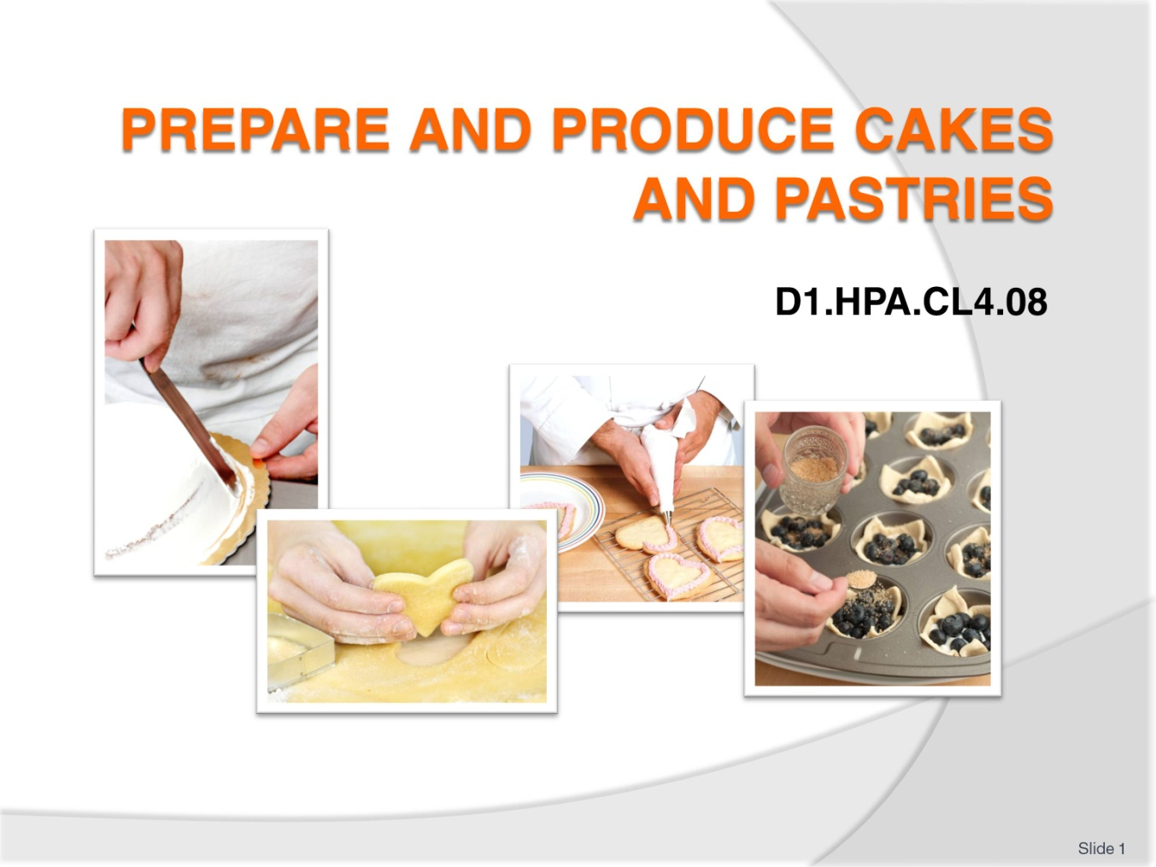
Slide No | Trainer Notes
Trainer to introduce self and talk of personal bone fide to be able to teach this unit.
Give brief overview of your experience in patisserie and baking Industry.

Slide
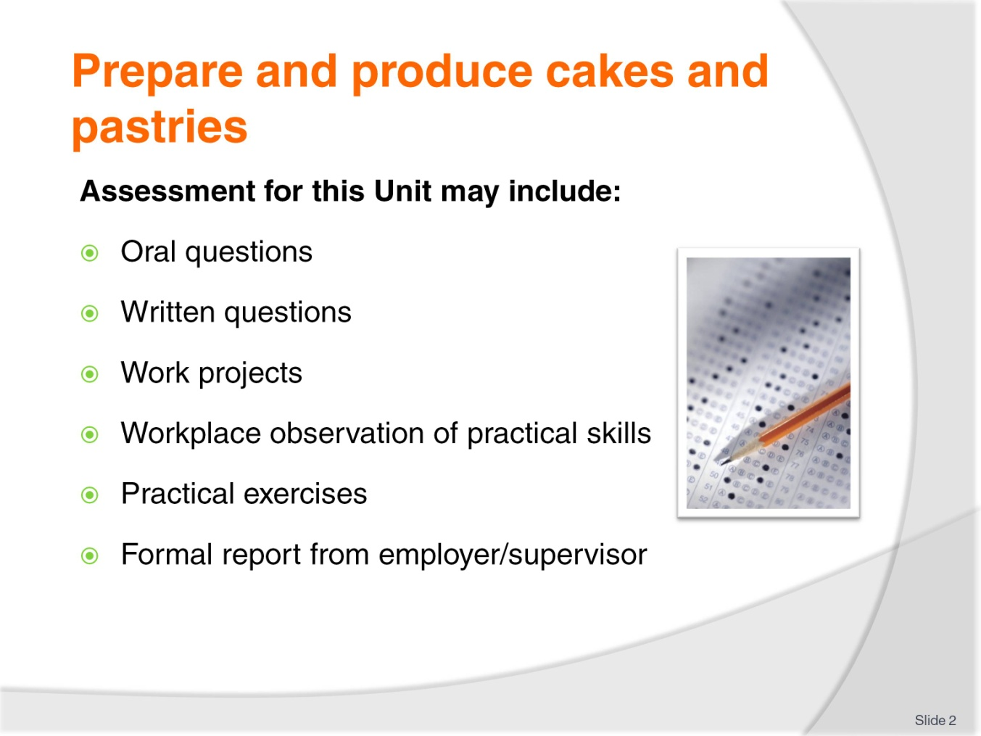
Slide No | Trainer Notes
Trainer advises students that assessment for this Unit may take several forms all of which are aimed at verifying they have achieved competency for the Unit as required.
Trainer indicates to students the methods of assessment that will be applied to them for this Unit.

Slide
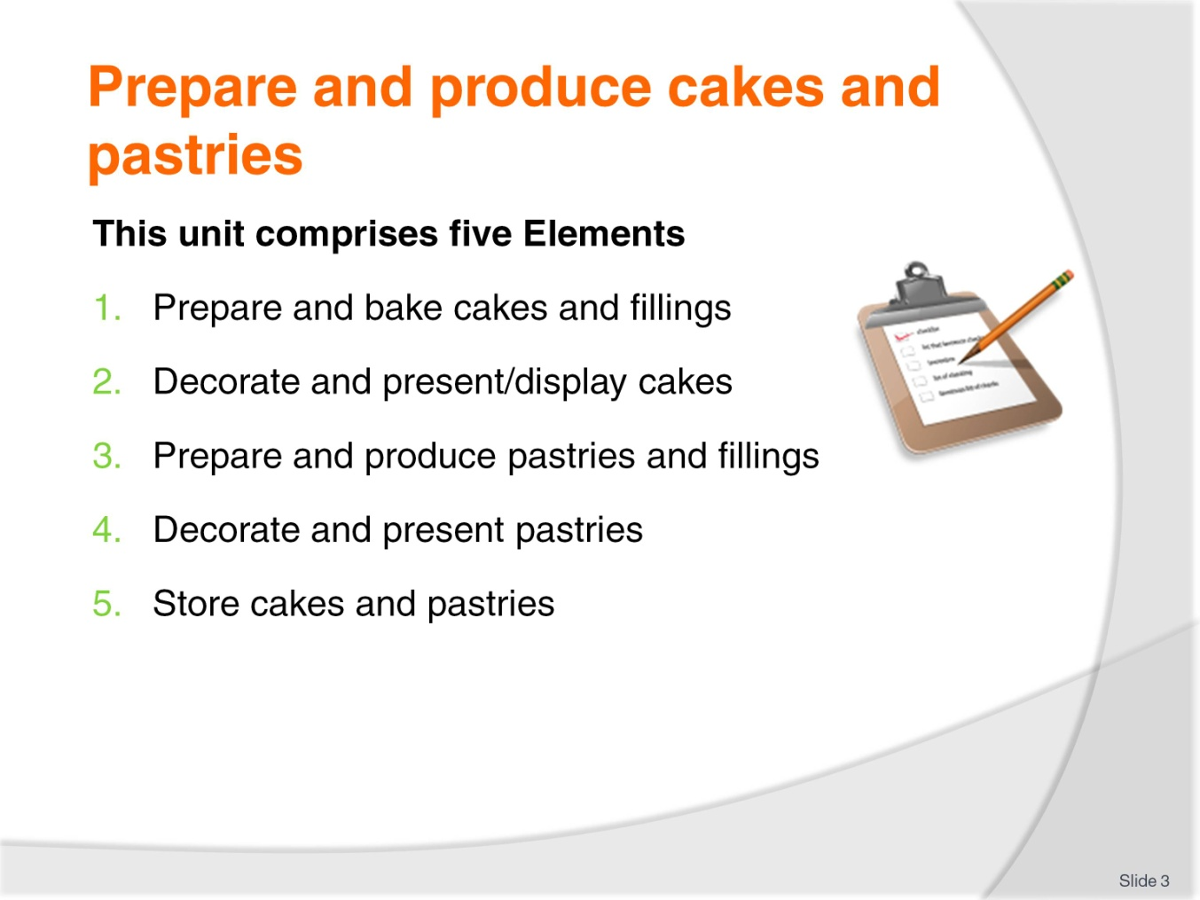
Slide No | Trainer Notes
Trainer advises students this Unit comprises five Elements, as listed on the slide explaining:
Each Element comprises a number of Performance Criteria which will be identified throughout the class and explained in detail
Students can obtain more detail from their Trainee Manual
The course presents advice and information but where their workplace requirements differ to what is presented, the workplace practices and standards must be observed.

Slide
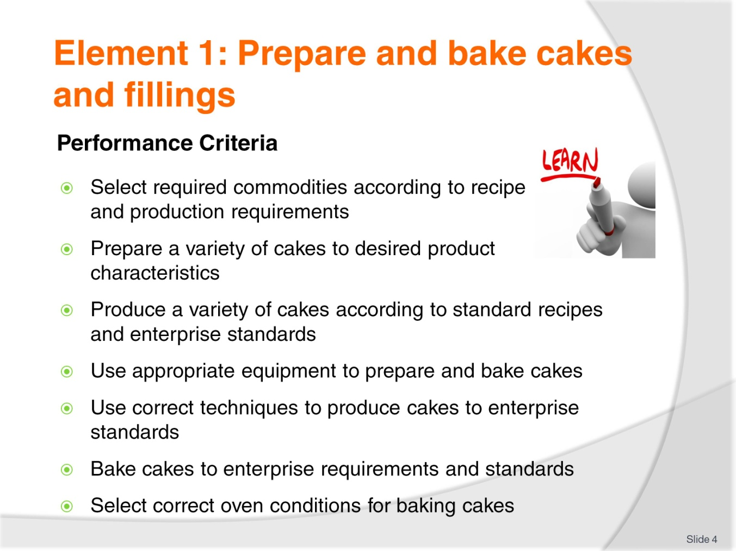
Slide No | Trainer Notes
Trainer to discuss:
Performance criteria relating to Element 1 - Prepare and bake cakes and fillings.

Slide
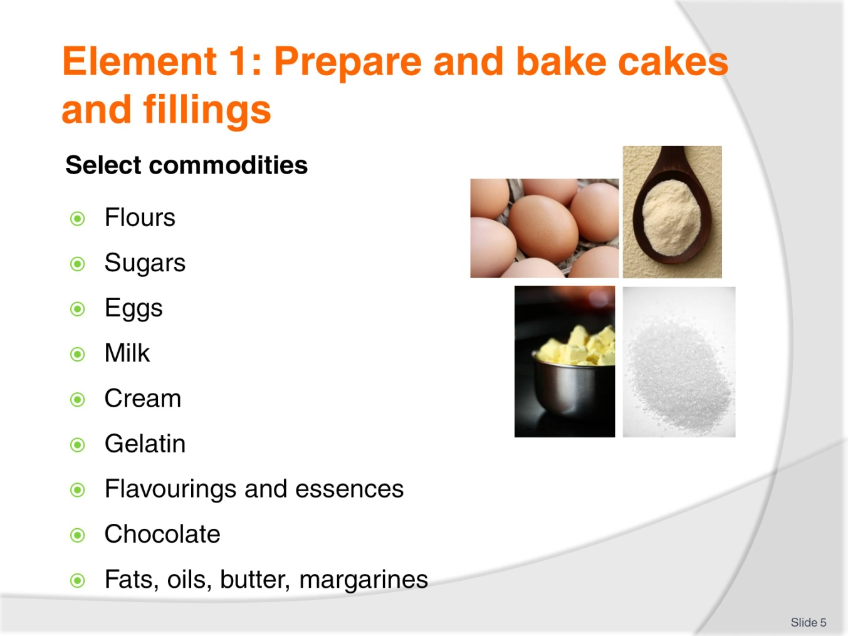
Slide No | Trainer Notes
Trainer to discuss:
Give a brief synopsis of all the ingredients that may be used to produces cakes and pastries.

Slide
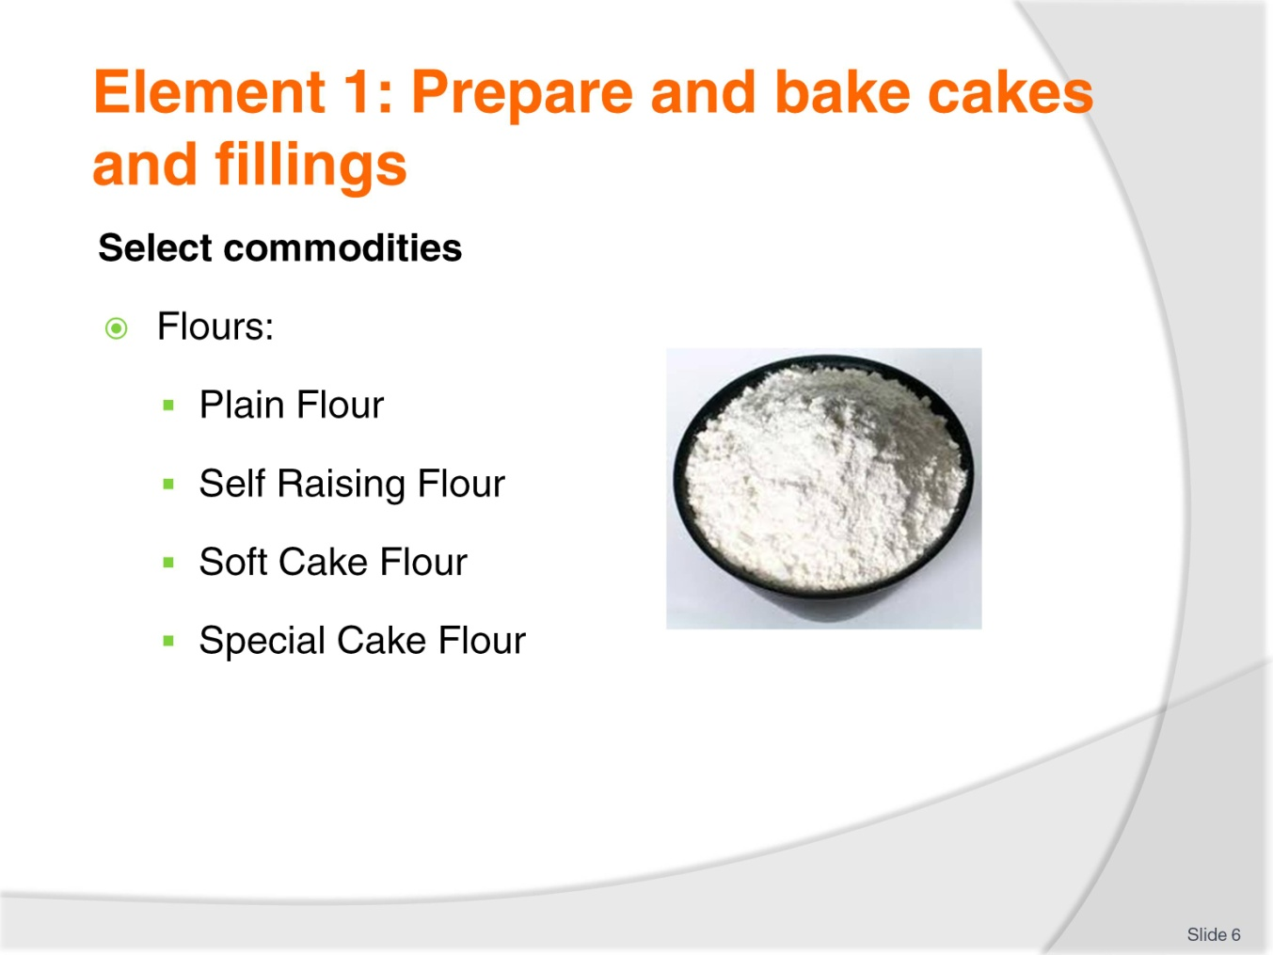
Slide No | Trainer Notes
Trainer to discuss:
There are many different types of flour on the market for making cakes
They are different to bread baking flours, they do not have the same gluten content
They are weaker in gluten
But of equal food value.
Each have a different role:
Plain Flour
General purpose flour that can be used across wide variety of goods.
Self Raising Flour
Plain flour that has an aerating agent (baking powder) added. 60g per kilo of flour is standard
Variation can be used but the majority of premixed self raising flour is in this ratio.
Soft Cake Flour
Plain flour with low gluten content that has been finely milled to allow for more surface area to be able to absorb and hold liquid.

Special Cake Flour
Flour which has had the protein denatured by being chlorinated after milling
This has a bleaching effect and makes the flour appear whiter
The flour has been finely milled so it has smaller particle size. This finer size allows for greater ability to hold liquid
This Special flour works with special shortenings with emulsifiers that allow for all ingredients to be placed into the same bowl and will aerate during the mixing process
In contrast to sugar batter and flour batter methods.

Slide
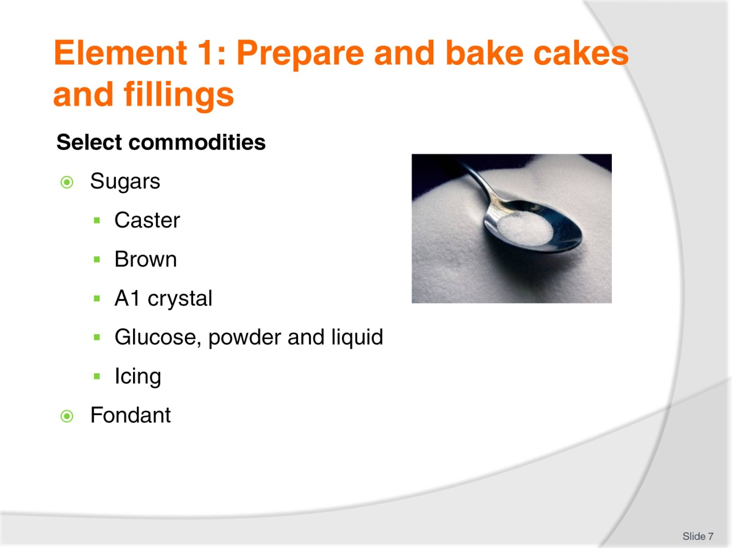
Slide No | Trainer Notes
Trainer to discuss:
Different types of sugar in the market place:
Castor sugar is the best sugar to use in cake making because it dissolves best during the baking process and less evidence of un-dissolved grains after baking
Brown sugar is normal sucrose that has a portion of molasses added to the end product
Brown sugar comes in light brown and dark brown
A1 sugar crystal is the normal everyday sugar that most people know. It is not recommended for baking due to the grain size. Castor sugar is best because it has finer grain and will dissolve better in batters and pastry during the baking process.
Glucose
Comes in either liquid or powder form
Liquid form is used in baking and its main role beside sweetening is to help keep moisture in product
Liquid glucose is derived from starch. The starch is gelatinised and an acid is added and over time it converts to a sugar; glucose.
Icing sugar
Finer grind of sugar, very small particles.
Fondant
Fondant is a sugar solution that has been boiled to 114-117C and then cooled and while cooling it is agitated to form a white mass
Before applying it needs to be tempered.

Slide
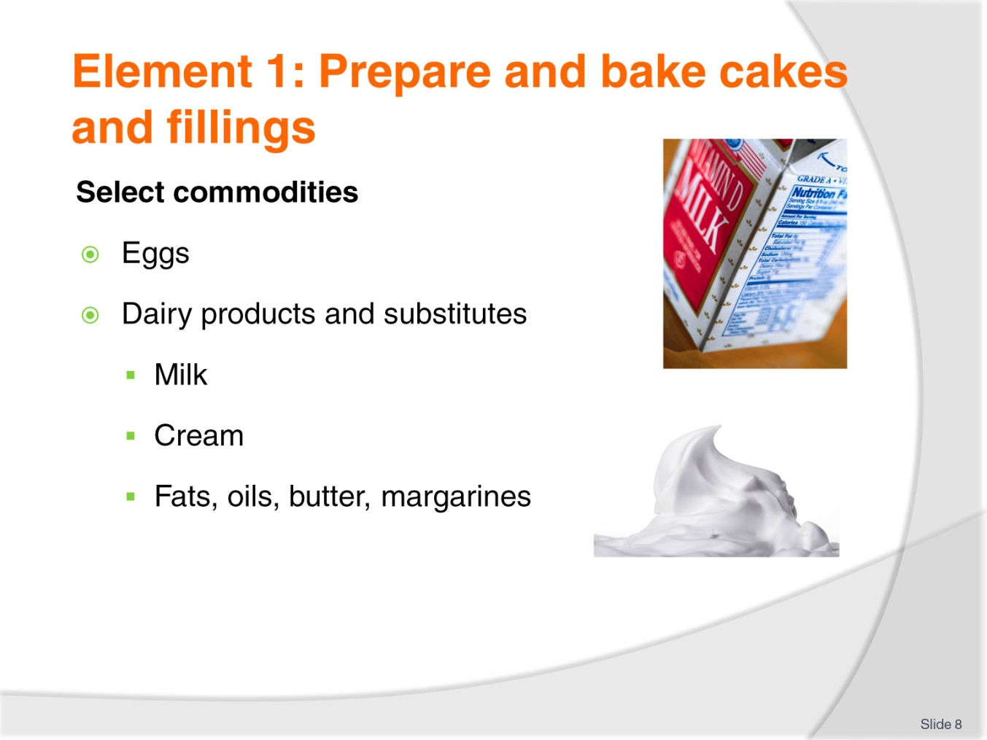
Slide No | Trainer Notes
Trainer to discuss:
Products in the marketplace:
Eggs
- Are available in many forms
- Fresh, frozen, powdered
Milk comes in several forms, fresh, powdered
- Cream comes both fresh and imitation
- Fresh need refrigeration and is hard to control in hot humid climates
Fats, oils, butter, margarines
- All are fats and come in many forms
- Practitioner needs to choose what is best adapted to the needs of the product.

Slide
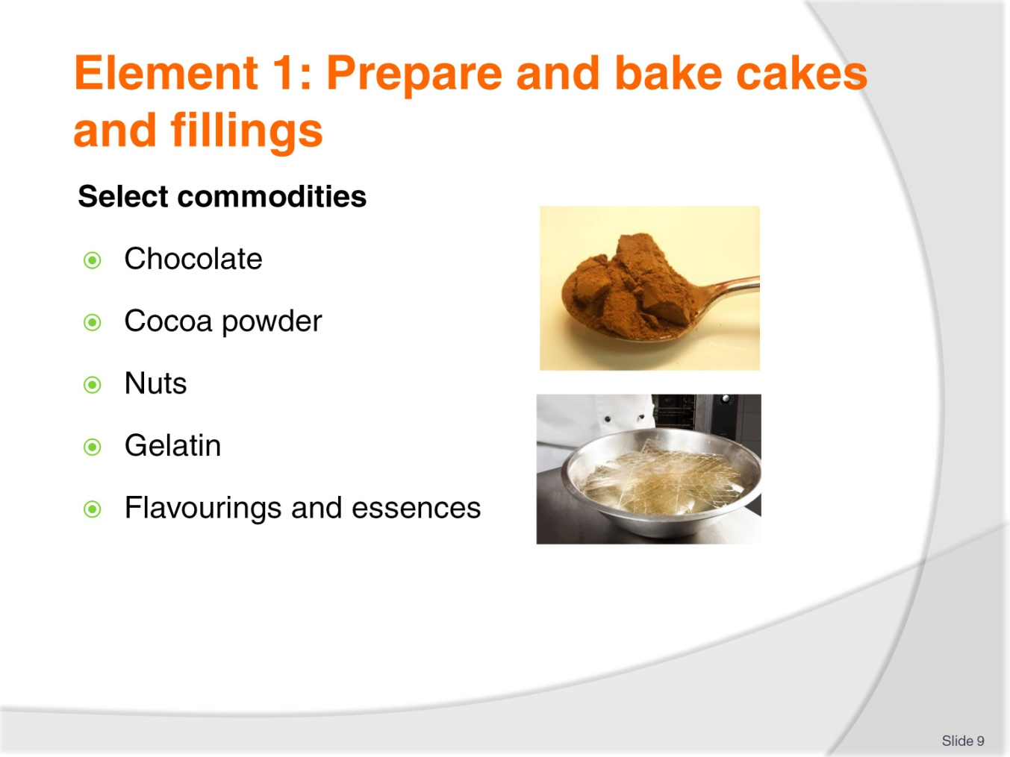
Slide No | Trainer Notes
Trainer to discuss:
Products in the marketplace:
Chocolate
- Cocoa powder
- Chocolate coverture and bakers chocolate can be used
- Cocoa powder is the powder flavour of the cocoa pod
Nuts
- Ground varieties are used in bakery products, sliced and chopped may be roasted and used for decoration
Gelatin and agar agar are just two gelling agents that can be used
Flavourings and essences
- Spices and liquid flavourings and colourings are also used, varieties are endless.

Slide
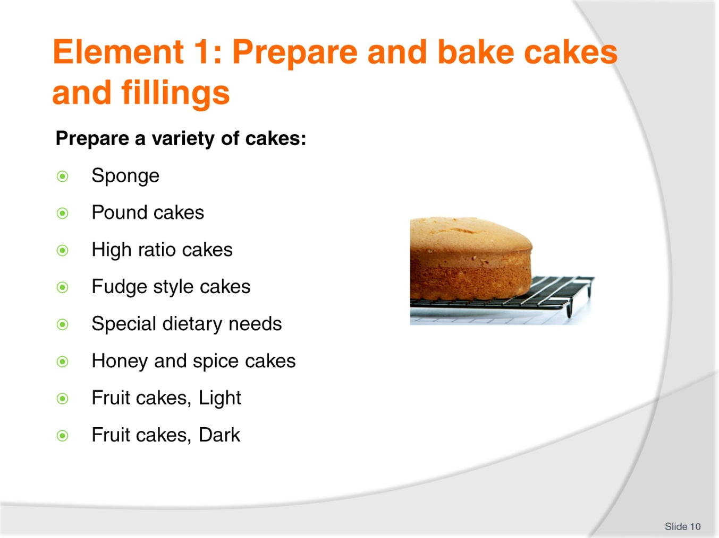
Slide No | Trainer Notes
Trainer to discuss:
Each of the following in the subsequent slides:
Pound cakes
High ratio cakes
Fudge style cakes
Special dietary needs
Honey and spice cakes
Fruit cakes, Light
Fruit cakes, Dark.

Slide
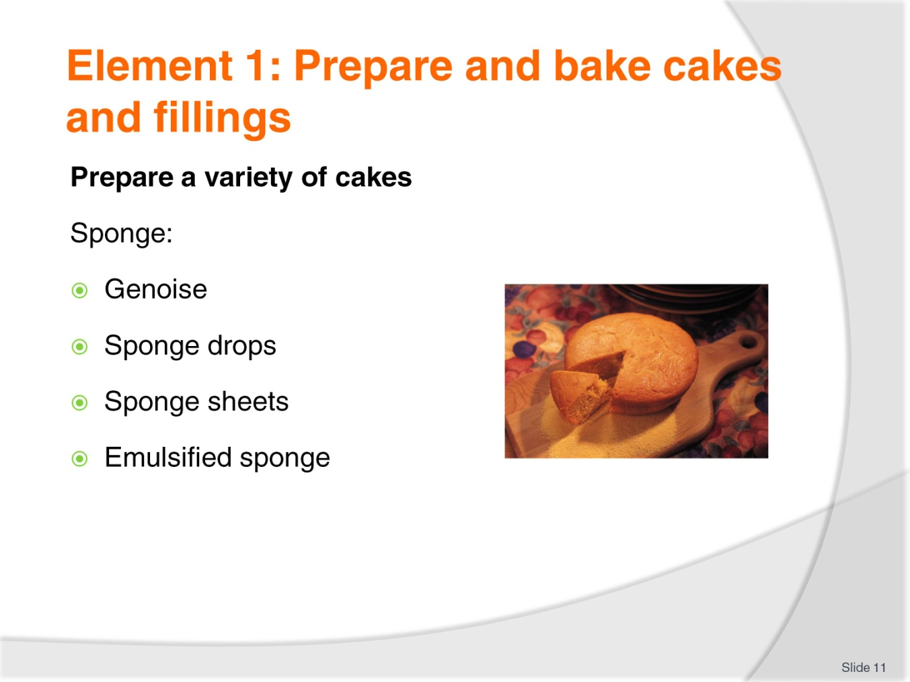
Slide No | Trainer Notes
Trainer to discuss:
What are sponge cakes and how to prepare them:
Genoise
Sponge drops
Sponge sheets
Emulsified sponge.

Slide
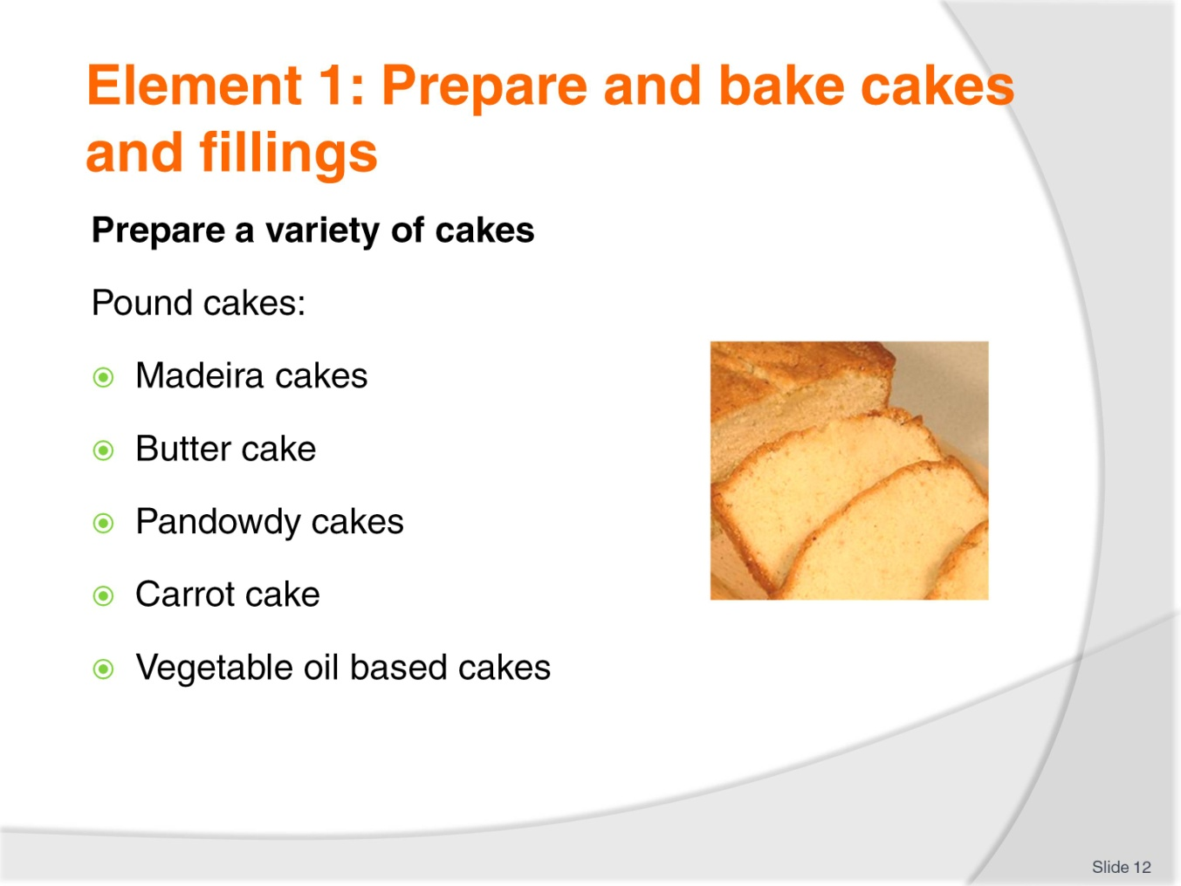
Slide No | Trainer Notes
Trainer to discuss:
The different varieties of pound cakes and their preparation:
Madeira cakes
Butter cake
Pandowdy cakes
Carrot cake
Vegetable oil based cakes.

Slide
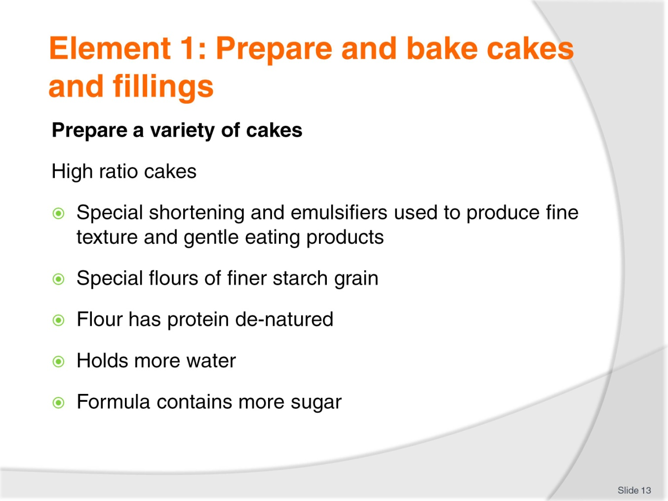
Slide No | Trainer Notes
Trainer to discuss:
What are High ratio cakes and their preparation method:
- Special shortening and emulsifiers used to produce fine texture and gentle eating products
- Special flours of finer starch grain
- Flour has protein de-natured
- Holds more water
- Formula contains more sugar.

Slide
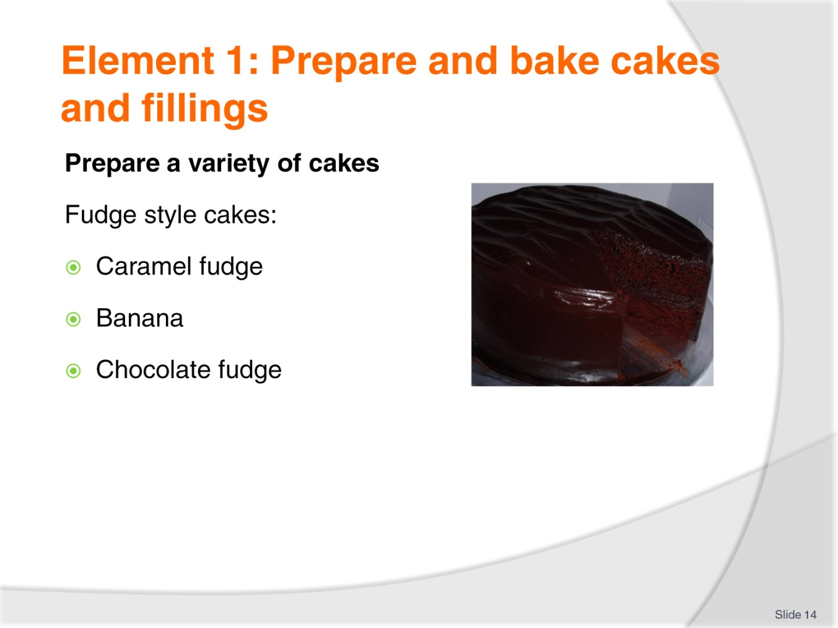
Slide No | Trainer Notes
Trainer to discuss:
What are Fudge style cakes, their varieties and preparation methods:
Caramel fudge
Banana
Chocolate fudge.

Slide
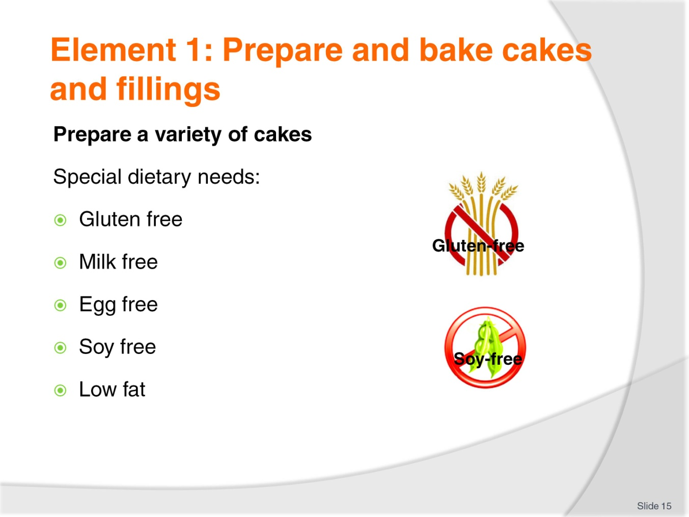
Slide No | Trainer Notes
Trainer to discuss:
What are the special dietary needs in preparing cakes:
Gluten free
Milk free
Egg free
Soy free
Low fat.

Slide
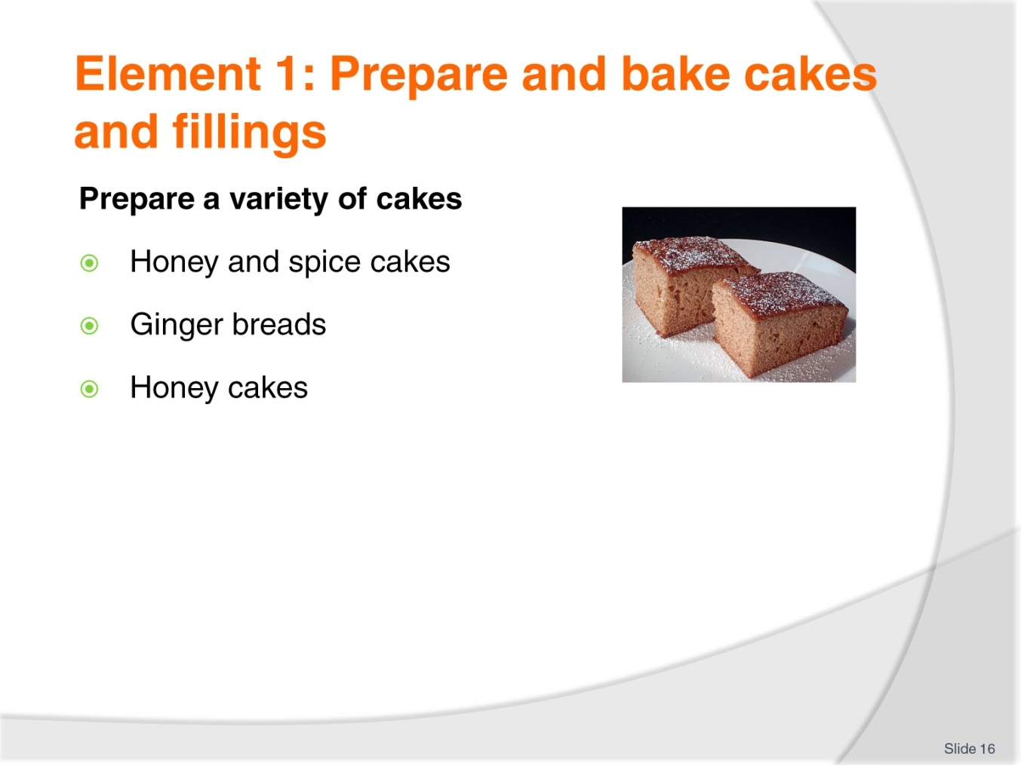
Slide No | Trainer Notes
Trainer to discuss:
Other varieties of cakes such as:
Honey and spice cakes
Ginger breads
Honey cakes.

Slide
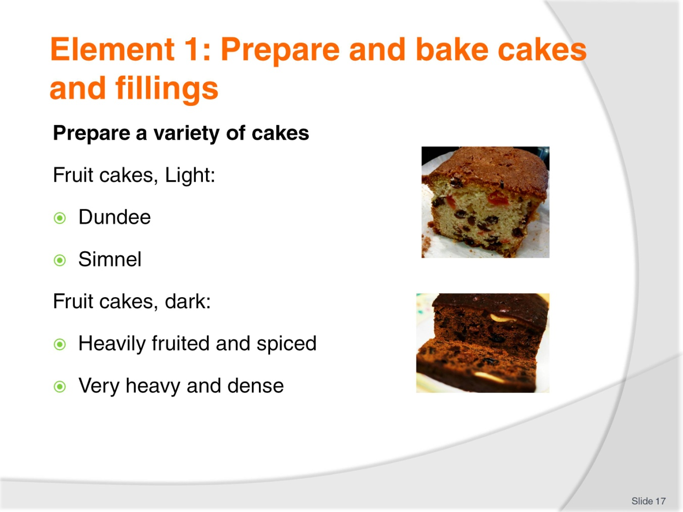
Slide No | Trainer Notes
Trainer to discuss:
The different types and characteristics of fruit cakes:
Fruit cakes - light
Fruit cakes – dark.

Slide
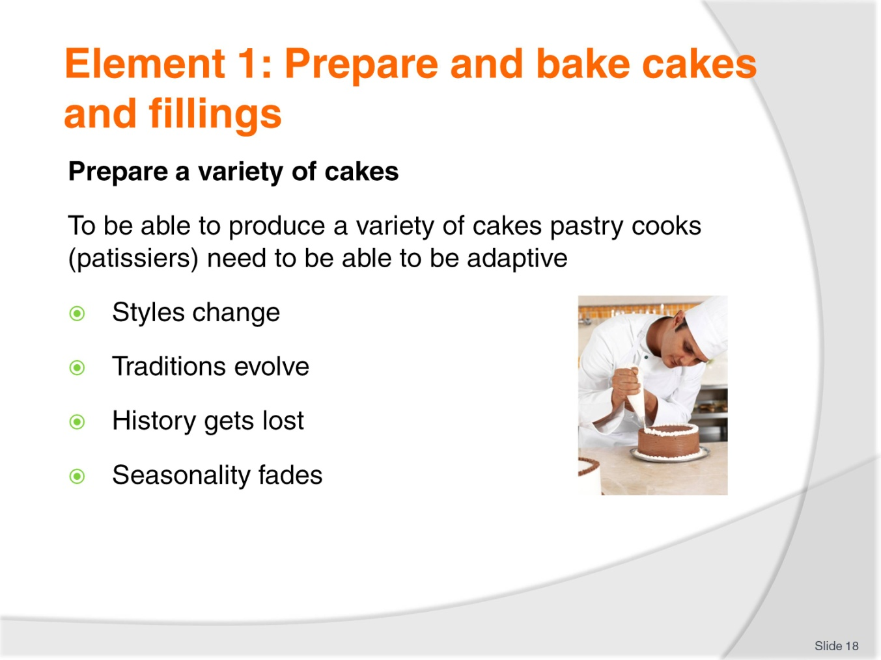
Slide No | Trainer Notes
Trainer to discuss:
The importance of being adaptive in order to produce a wide variety of cakes due to the following reasons:
Styles change
Traditions evolve
History gets lost
Seasonality fades.

Slide
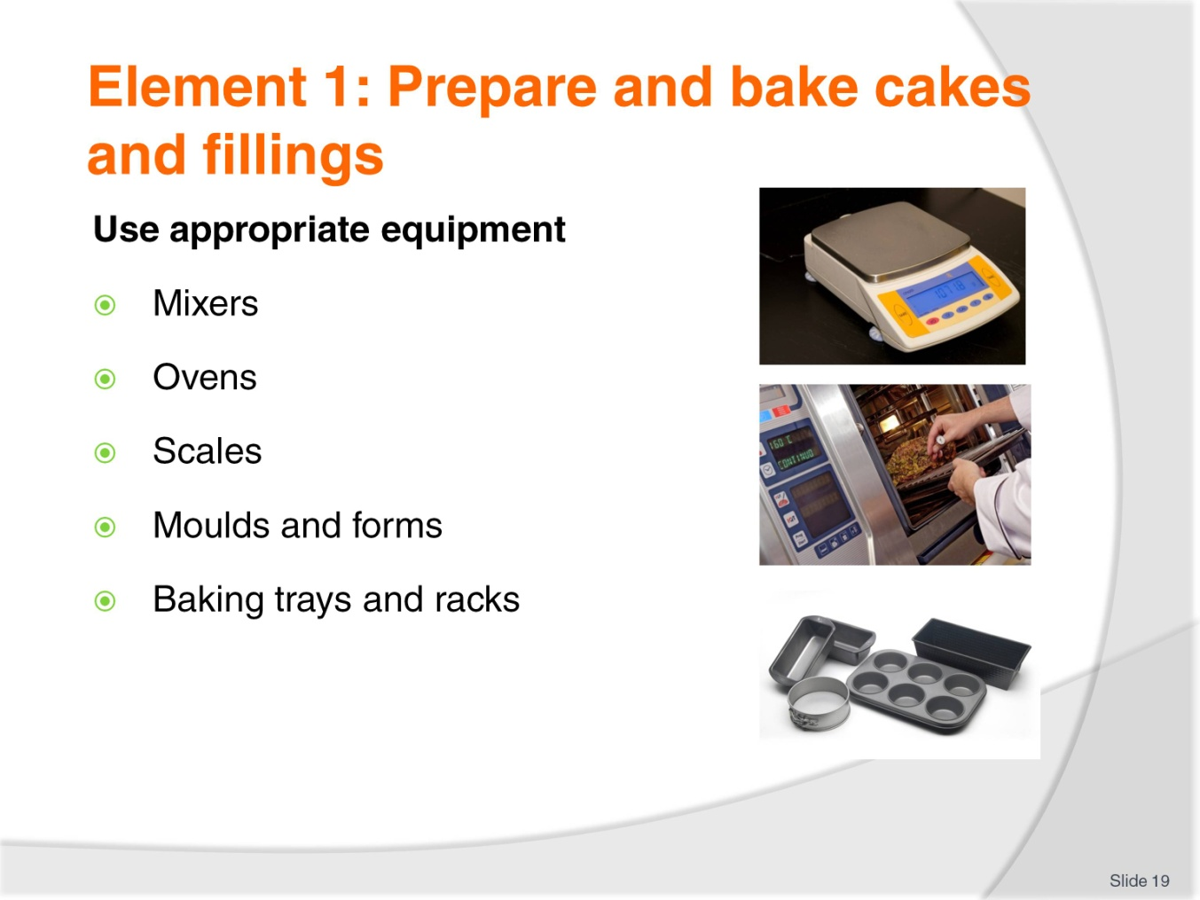
Slide No | Trainer Notes
Trainer to discuss:
The appropriate equipment to prepare and bake cakes and fillings.

Slide
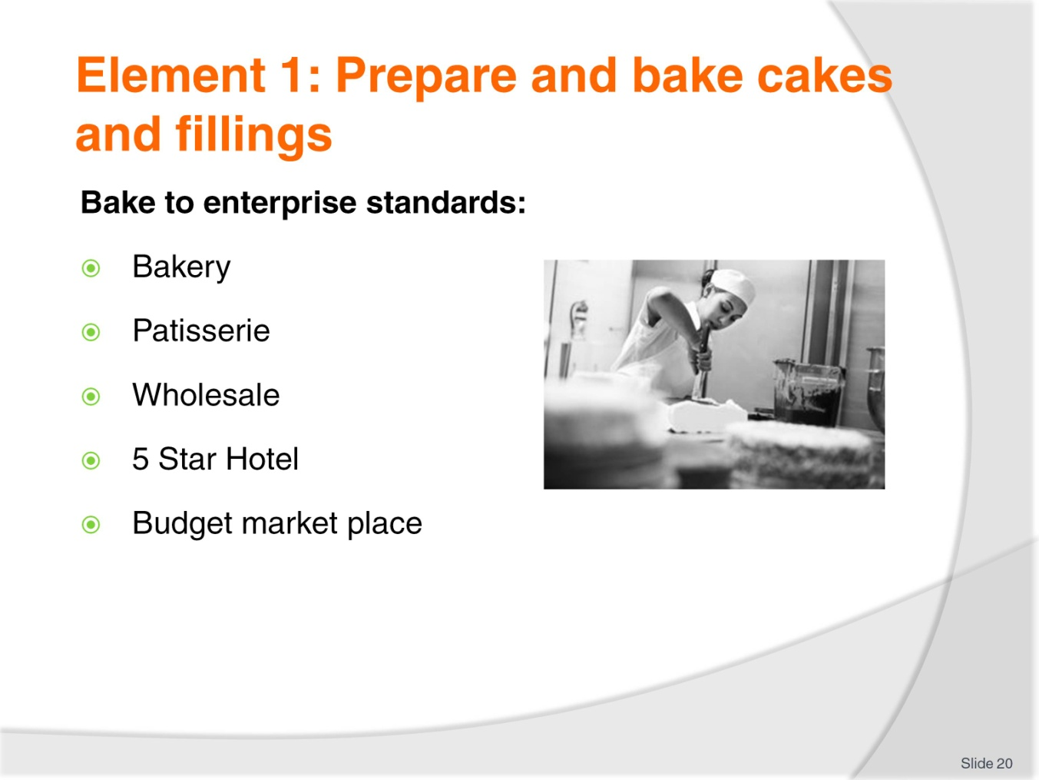
Slide No | Trainer Notes
Trainer to discuss:
The importance of baking to enterprise standards.

Slide
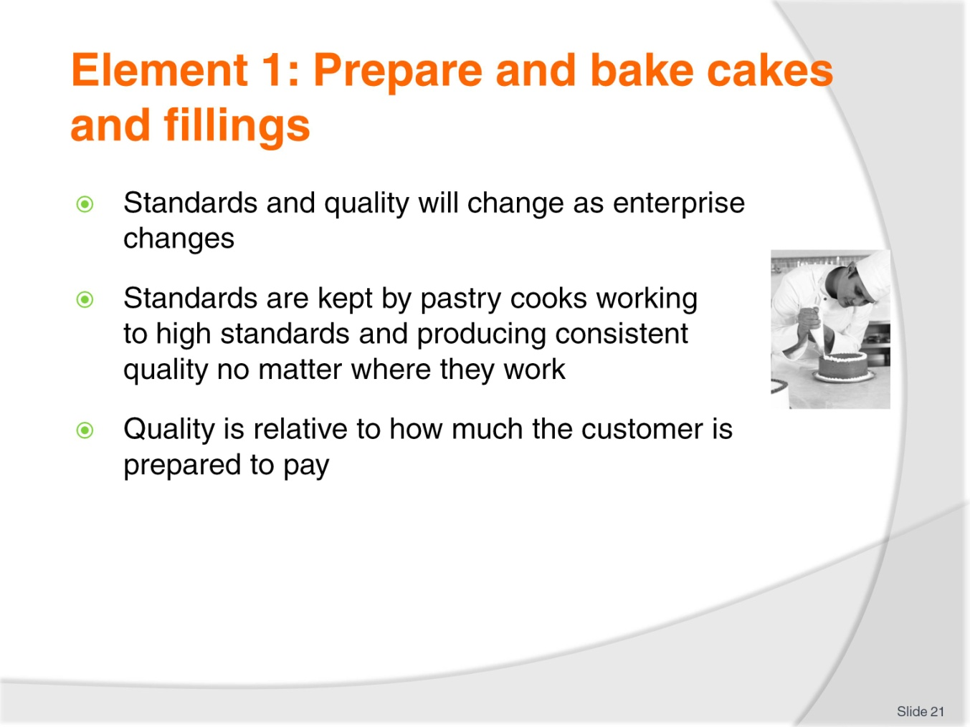
Slide No | Trainer Notes
Trainer to discuss:
Standards and quality will change as enterprise changes
Standards are kept by pastry cooks working to high standards and producing consistent quality no matter where they work
Quality is relative to how much the customer is prepared to pay.

Slide
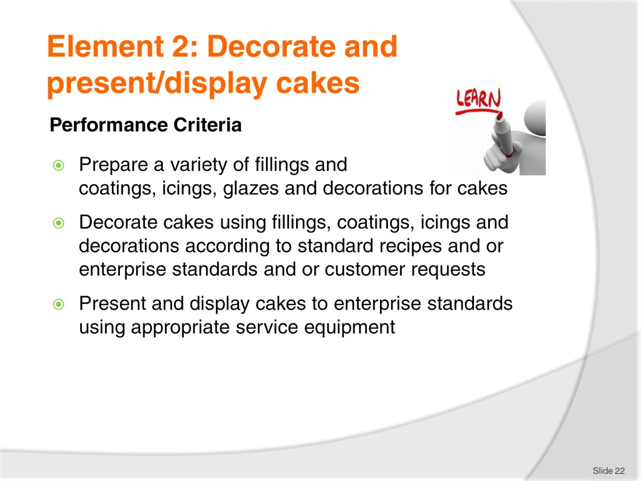
Slide No | Trainer Notes
Trainer to discuss:
Performance criteria relating to Element 2 - Decorate and present/display cakes.

Slide
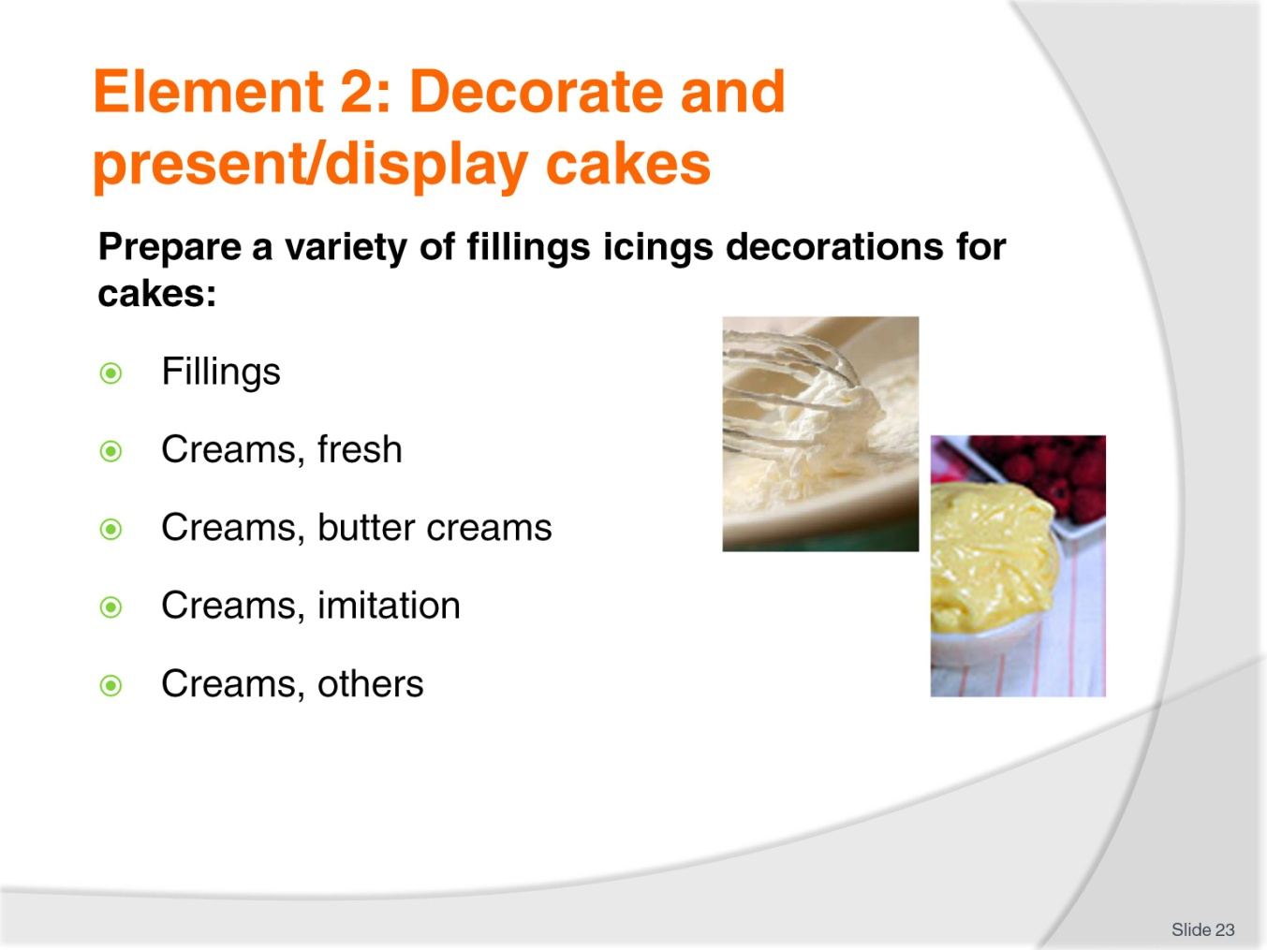
Slide No | Trainer Notes
Trainer to discuss:
The different types of fillings for cakes.

Slide
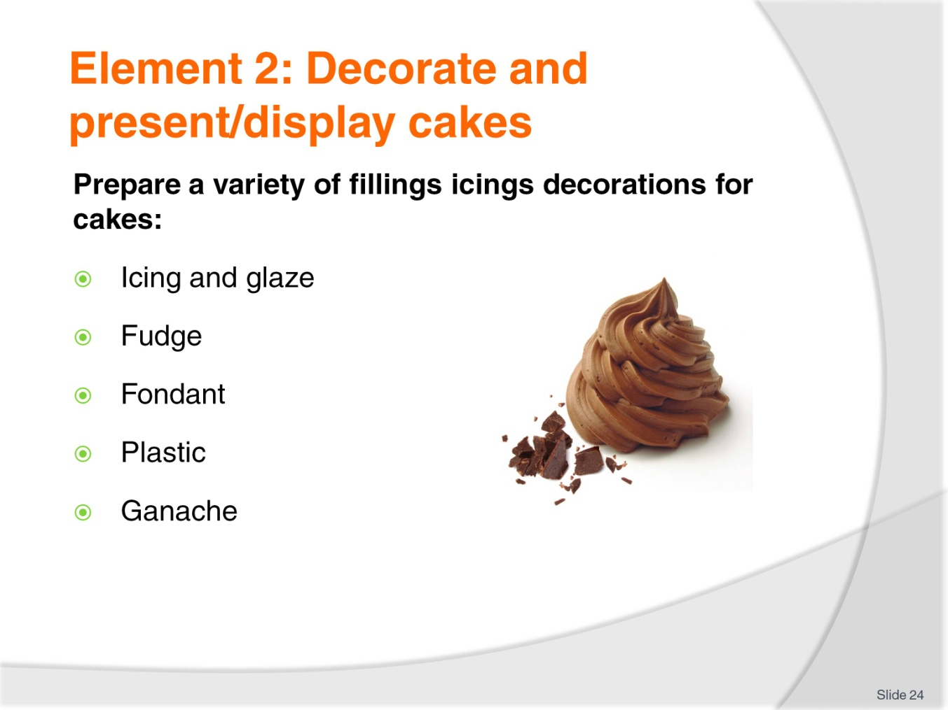
Slide No | Trainer Notes
Trainer to discuss and provide examples:
The different icings and decorations for cakes.

Slide
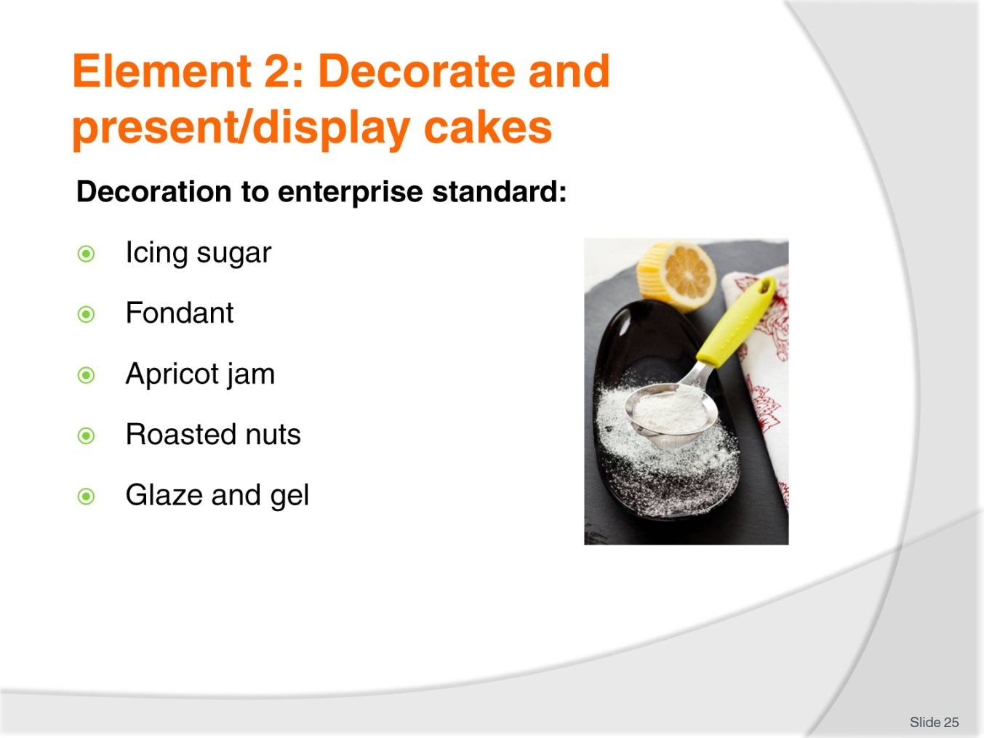
Slide No | Trainer Notes
Trainer to discuss:
Decoration is the final part of the production of any product
Some need no further additions
Some are added before the baking begins.
Icing Sugar
Sprinkled over product after it has come out of the oven
If sprinkled while product is still hot icing sugar has a tendency to bond to the product.
Con: when people go to eat the product and breath in it can cause people to cough,
Customers have to lick fingers after eating.
Fondant
Fondant is cooked sugar. It needs to be tempered so it will maintain the gloss or shine
Used in Australia and Europe extensively. Limited use in Asia due to availability and humid conditions.

Apricot jam
Boiling Apricot jam is applied to baked Danish and sweet yeast goods as a glaze. It must be applied to hot product so it will dry to touch when cool
Adds flavour and slows moisture migration from fondant icing and pastry.
Roasted Nuts
Sliced and roasted are commonly used to decorate Danish style pastries after baking
Can be expensive to use, use sparingly.
Glazes and gels
These are available in the commercial market. Seaweed based gels are used to apply a shine to finished product
Used mainly on Danish pastries with crème patisserie and fruit fillings
Protects form dehydration, exposure to the air.

Slide
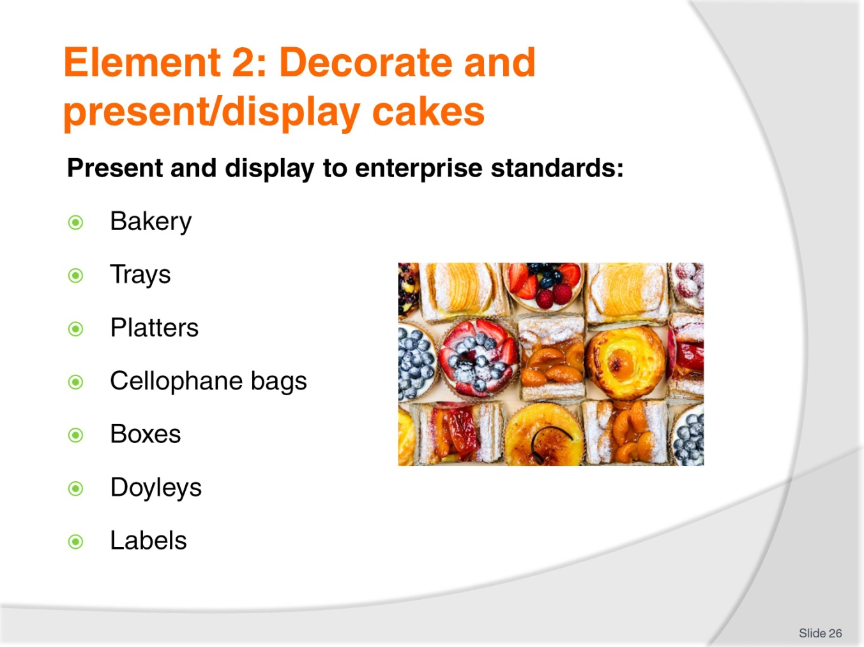
Slide No | Trainer Notes
Trainer to discuss:
Trays
After taking from oven product is placed onto cooling wires, decorated and then placed on trays or platters.
Doyleys
Some larger product might be placed on to a doyley and displayed individually. The role of the doyley is to have a barrier under product and protect from surface contamination.
Boxes
Product might be placed into boxes and displayed for sale, lots of 6 or 12
Some boxes might have seen through lids.
Cellophane bags
Bags are clear, see through. Product is placed inside bags to protect from outside contamination and to slow the staling process. Staling is caused by air passing through product and removing moisture. Or moisture evaporates from surface.
Labels
Packaged products will have label showing ingredients, name of manufacture and other legal requirements
They make good advertising.

Slide
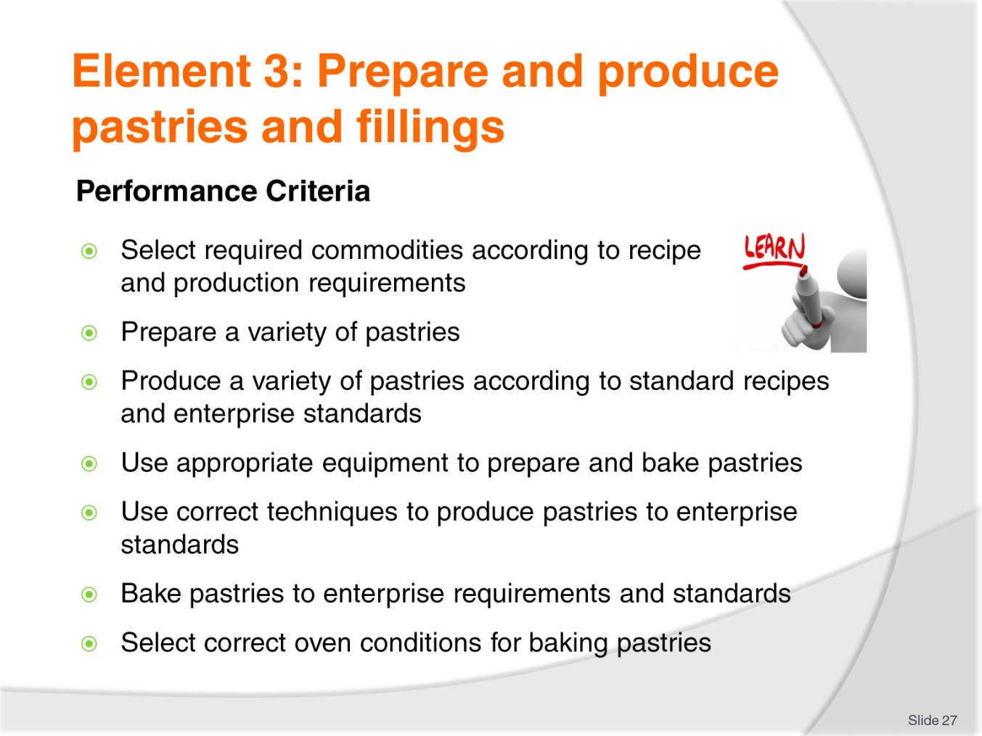
Slide No | Trainer Notes
Trainer to discuss:
Performance criteria relating to Element 3 - Prepare and produce pastries and fillings.

Slide
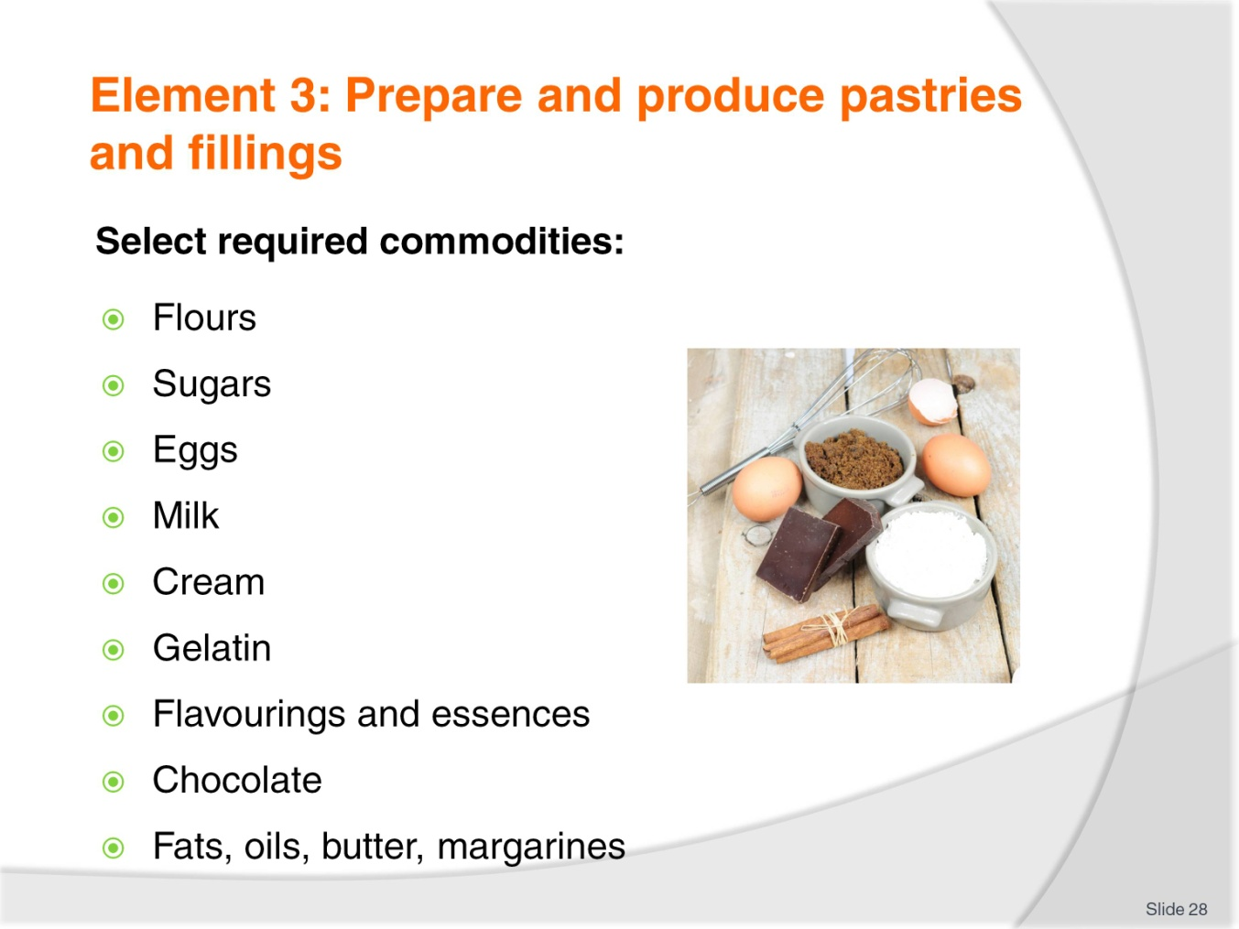
Slide No | Trainer Notes
Trainer to discuss:
The selection of required commodities in the preparation and production of pastries and fillings in the subsequent slides.

Slide
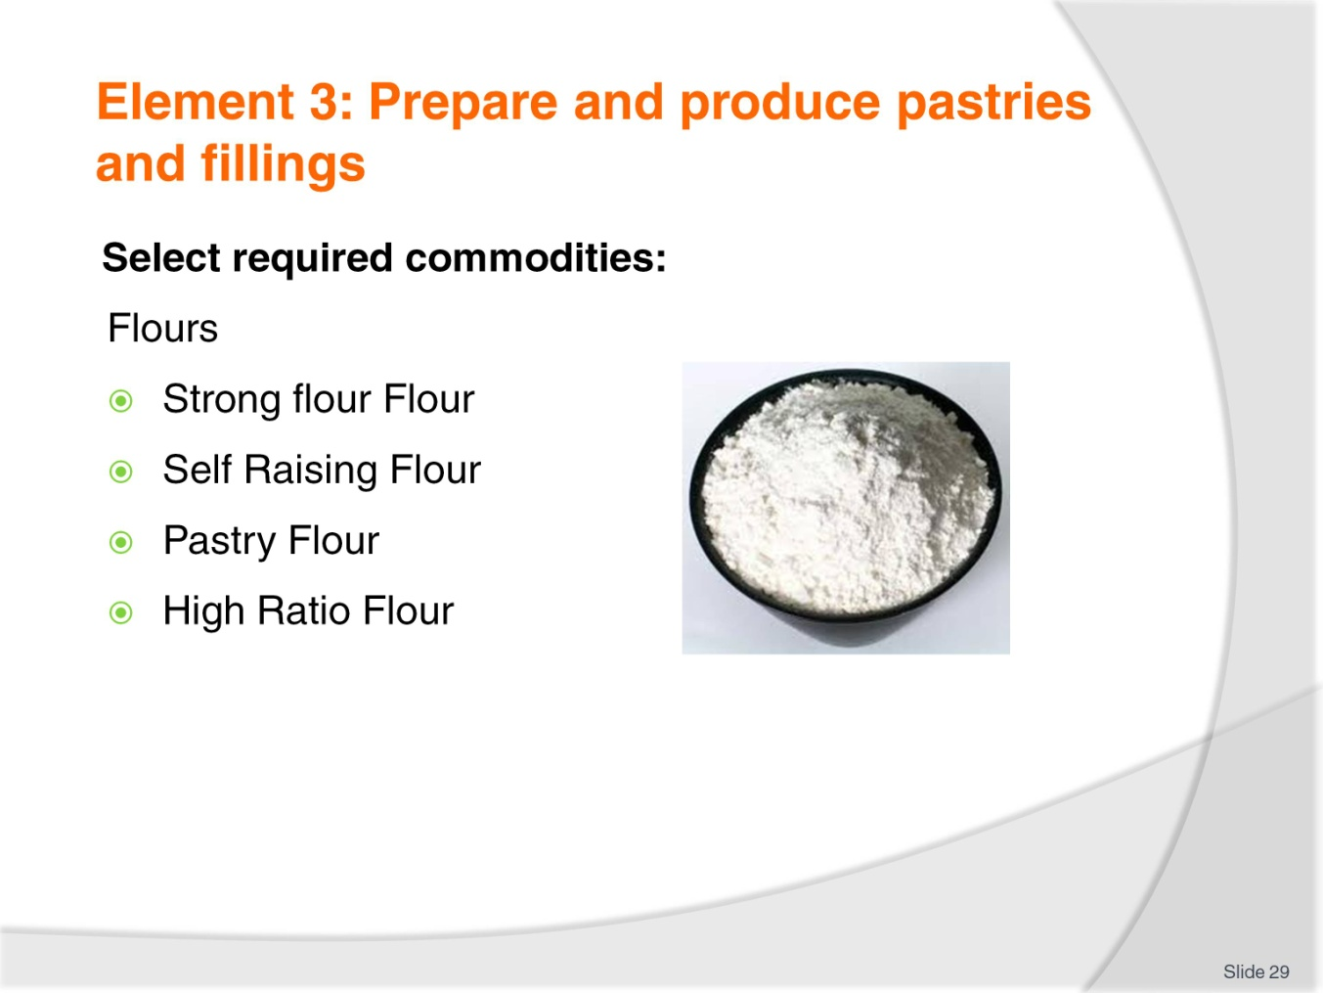
Slide No | Trainer Notes
Trainer to discuss:
There are many different types of flour on the market
Each have a different role
Gluten content is different in each.

Slide
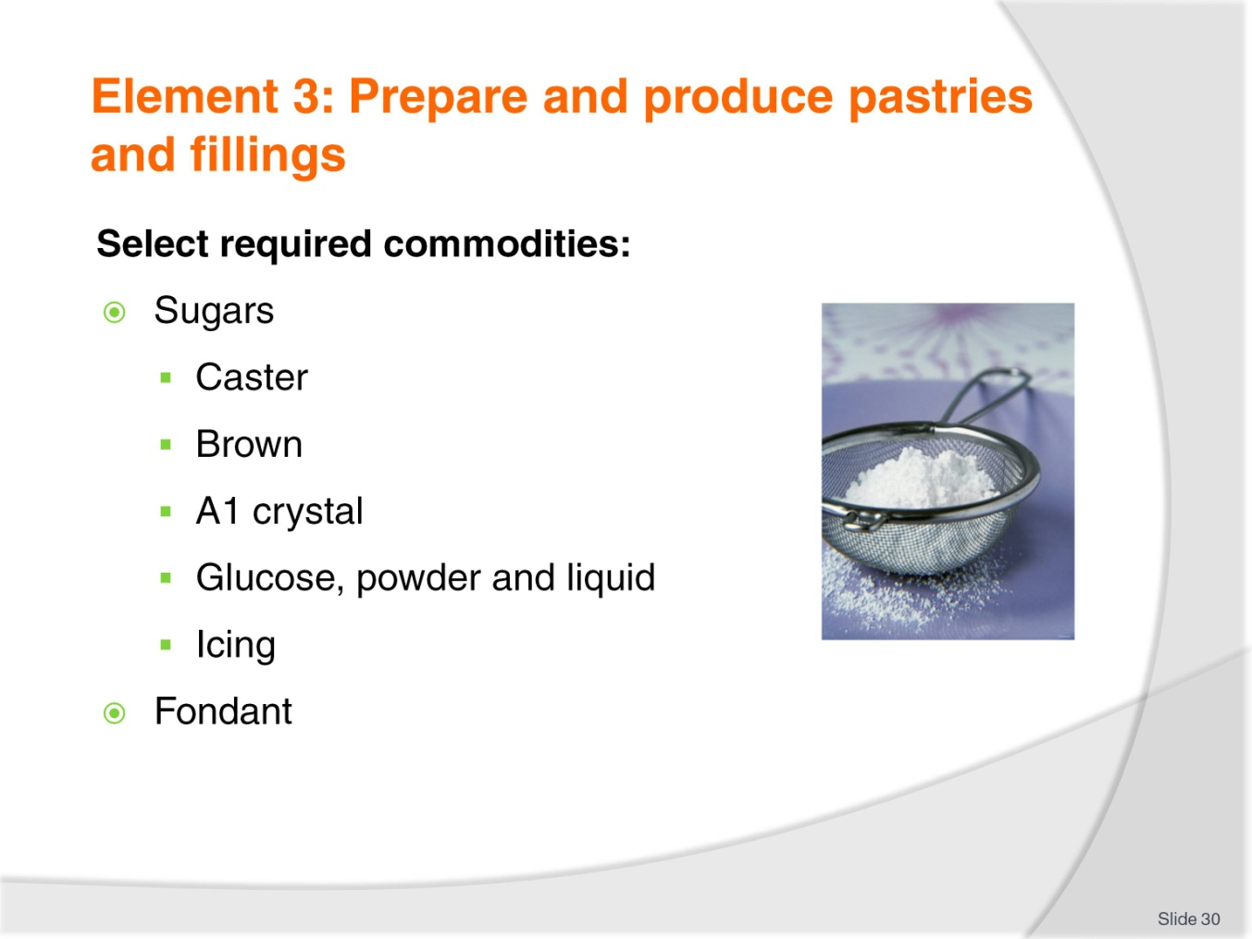
Slide No | Trainer Notes
Trainer to discuss:
Different types of sugar in the market place:
Castor sugar is the best sugar to use in cake making because it dissolves best during the baking process and less evidence of un-dissolved grains after baking
Brown sugar is normal sucrose that has a portion of molasses added to the end product
Brown sugar comes in light brown and dark brown
A1 sugar crystal is the normal everyday sugar that most people know. It is not recommended for baking due to the grain size. Castor sugar is best because it has finer grain and will dissolve better in batters and pastry during the baking process.
Glucose
Comes in either liquid or powder form
Liquid form is used in baking and its main role beside sweetening is to help keep moisture in product
Liquid glucose is derived from starch. The starch is gelatinised and an acid is added and over time it converts to a sugar; glucose.
Icing sugar
Finer grind of sugar, very small particles.
Fondant
Fondant is a sugar solution that has been boiled to 114-117C and then cooled and while cooling it is agitated to form a white mass
Before applying it needs to be tempered.

Slide
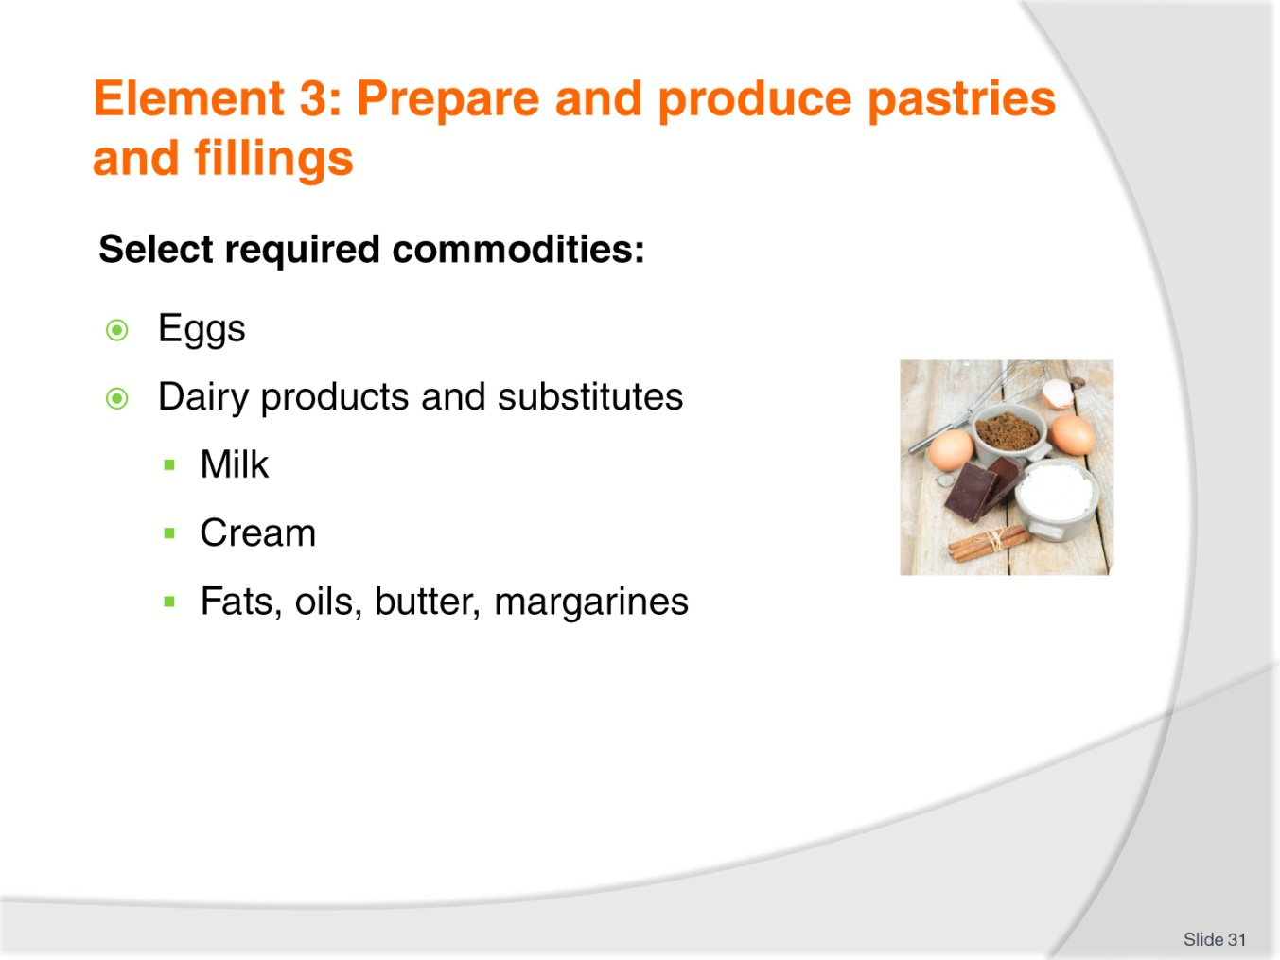
Slide No | Trainer Notes
Trainer to discuss:
Products in the marketplace:
- Eggs
Are available in many forms
Fresh, frozen, powdered
- Milk comes in several forms, fresh, powdered
Cream comes both fresh and imitation
Fresh need refrigeration and is hard to control in hot humid climates
- Fats, oils, butter, margarines
All are fats and come in many forms
Practitioner needs to choose what is best adapted to the needs of the product.

Slide
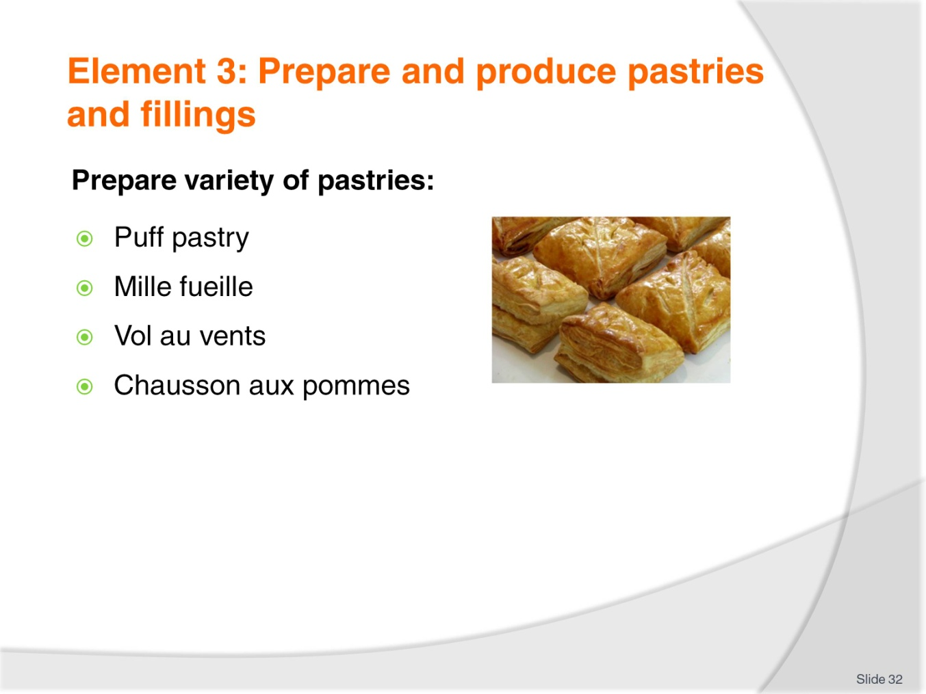
Slide No | Trainer Notes
Trainer to discuss:
Examples of items made from each of these pastry varieties.

Slide
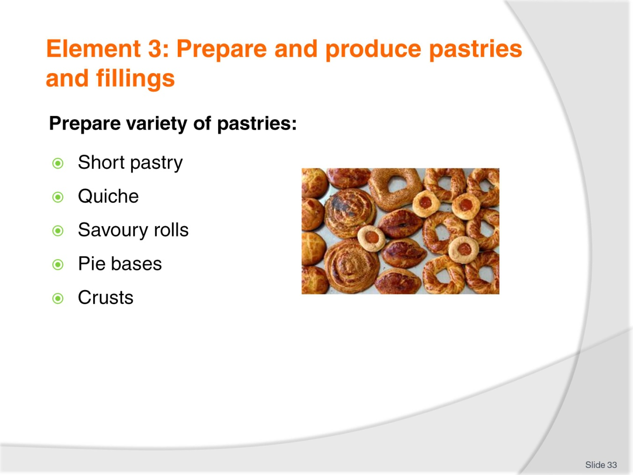
Slide No | Trainer Notes
Trainer to discuss:
Examples of items made from each of these pastry varieties.

Slide
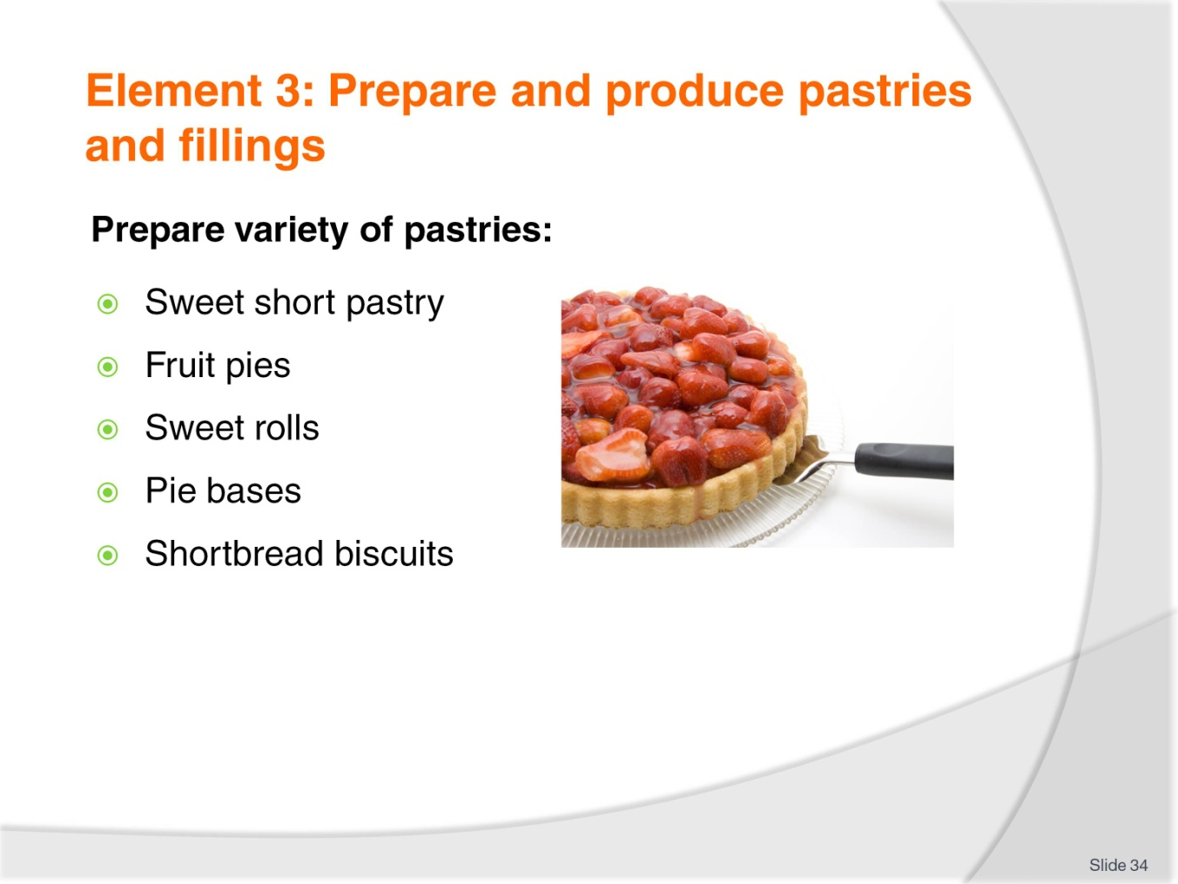
Slide No | Trainer Notes
Trainer to discuss:
Examples of items made from each of these pastry varieties.

Slide
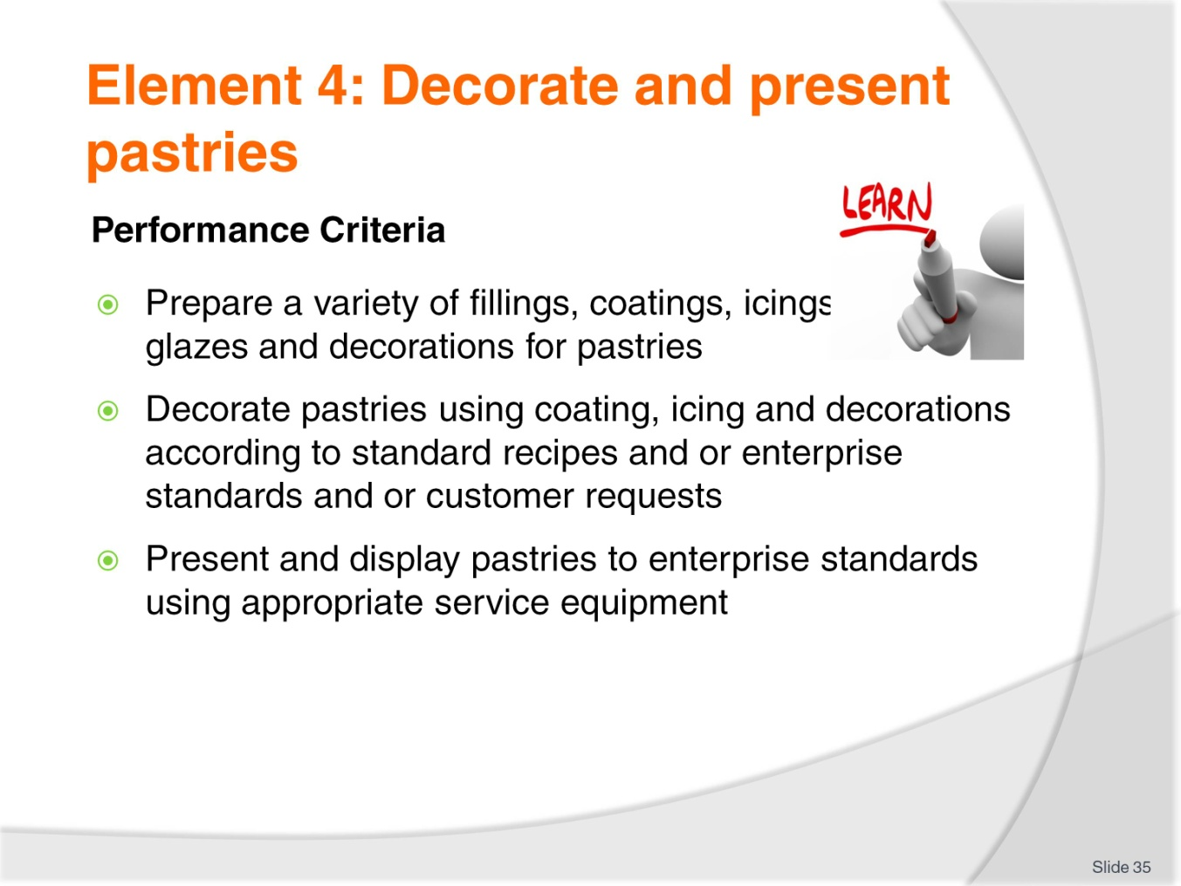
Slide No | Trainer Notes
Trainer to discuss:
Performance criteria relating to Element 4 - Decorate and present pastries.

Slide
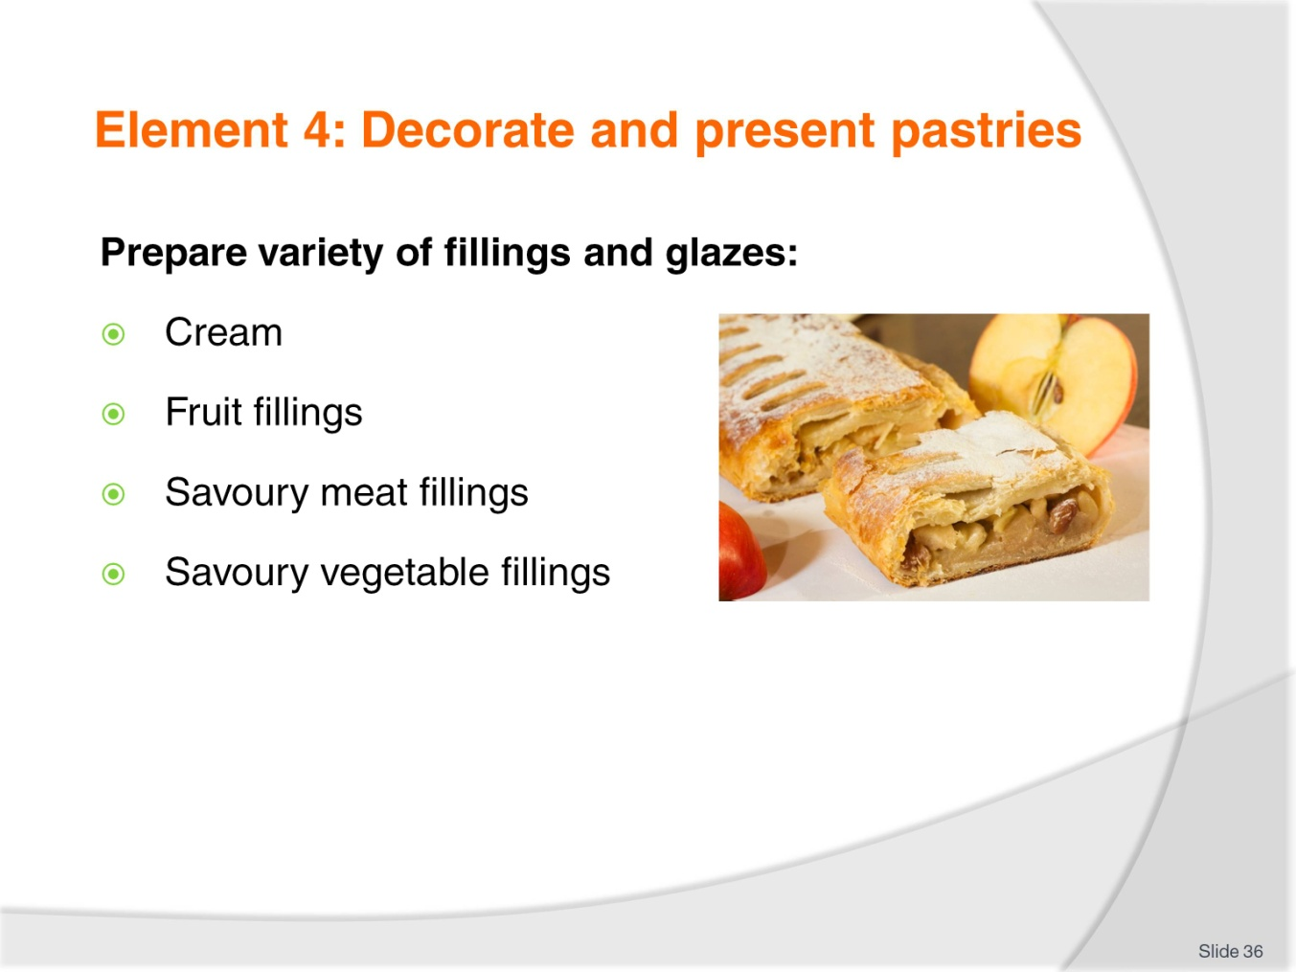
Slide No | Trainer Notes
Trainer to discuss:
Examples of the use of these fillings in producing various items/dishes.

Slide
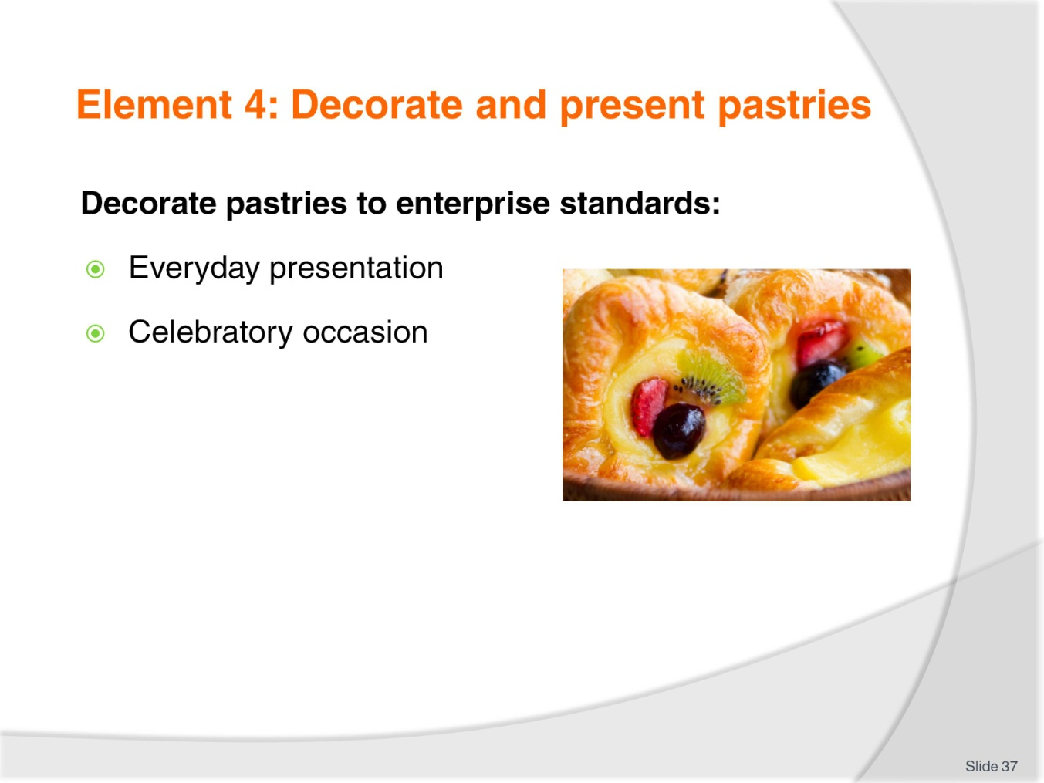
Slide No | Trainer Notes
Trainer to discuss:
Examples of everyday presentation and examples of a variety of celebratory occasions.

Slide
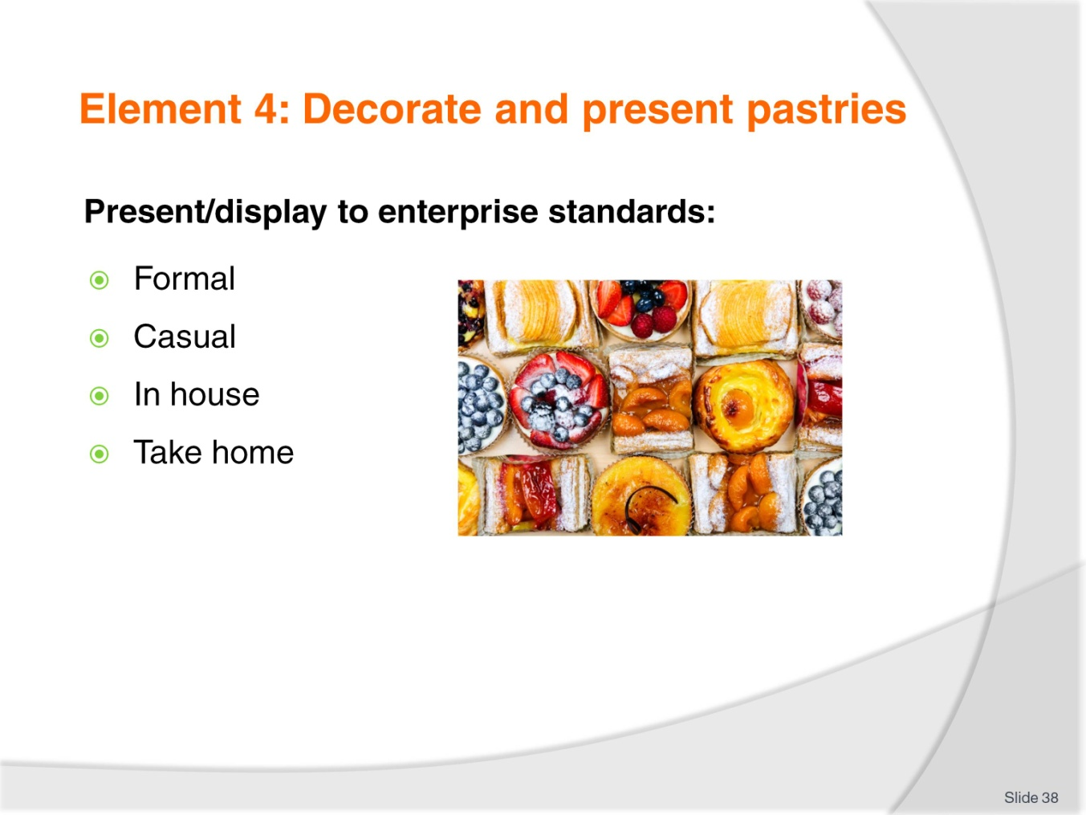
Slide No | Trainer Notes
Trainer to discuss:
The decoration and presentation of pastries needs to take into account the setting and the use of the pastry items.
Ask the class to provide examples for each of the following:
Formal
Casual
In house
Take home.

Slide
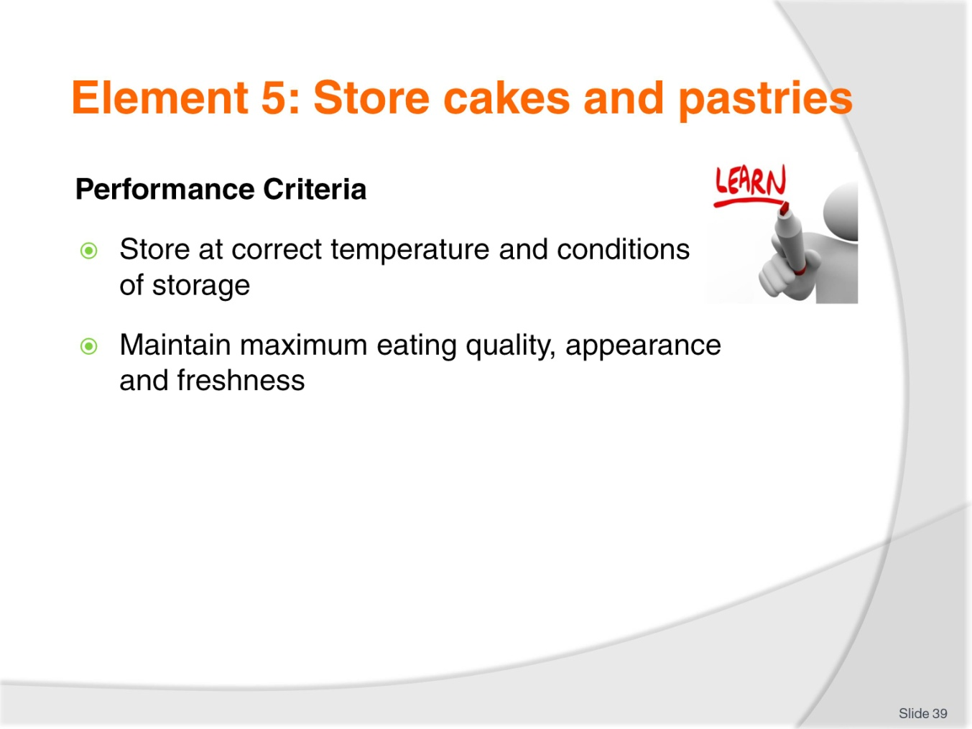
Slide No | Trainer Notes
Trainer to discuss:
Performance criteria relating to Element 5 - Store cakes and pastries.

Slide
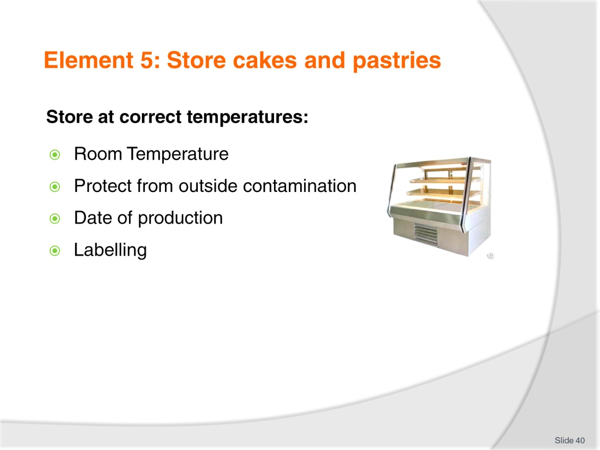
Slide No | Trainer Notes
Trainer to discuss:
The important aspects of each of these:
Room Temperature – Discuss variations of room temperature in various climates, particular emphasis on heat and humidity in Southeast Asian nations
Protect from outside contamination – Discuss various forms of contamination including chemical, biological and vermin/pests
Date of production – Discuss the importance of absolute freshness in pastry products
Labelling – As with all fresh food products, complete and correct labelling is vital.

Slide
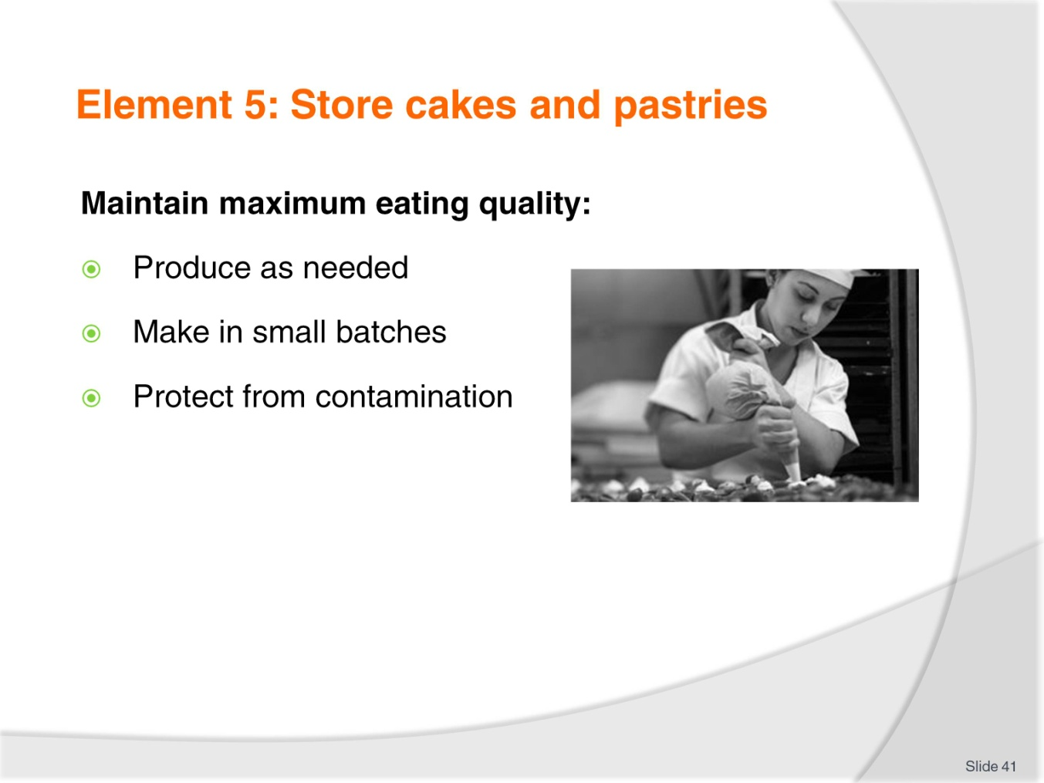
Slide No | Trainer Notes
Trainer to discuss:
Produce as needed
- Produce only what is required as the product will stale quickly and eating quality will diminish
Make in small batches
- Smaller batches will keep quality at maximum
Protect from contamination
- Keep covered to protect from outside contamination and slow staling process.

Recommended training equipment
The equipment and kitchen consumables required for the delivery of practical patisserie training classes are listed below, in the following categories:
A: Items of equipment which should be available for trainer and student use in the training kitchen
B: The cleaning equipment and cleaning products which should be available in a cleaning room located adjacent to the kitchen, so that students can clean down to leave the kitchen in “as found” condition at the end of each class or session
C: Consumables other than foodstuffs which need to kept in the kitchen and available for everyday use in each class or session
D: The items required by each student which would make up their own individual use kit of tools and small equipment.

A: Equipment in the training kitchen:
Baking ovens  Baking trays  Bakery racks for baking trays  Cooling wires  Proofers  Stainless steel benches or benches with washable surfaces  Stainless steel sinks  Dishwasher  Electronic scales or balance scales  Cake forms, round and square, rectangular  Cooking pots of various sizes  Sugar work kit | Pie forms  Quiche forms  Measuring jugs  Rolling pins  Food storage containers large and small  Tartlet moulds  Brioche moulds  Pastry docker  Baking paper  Silicon baking sheets  Sieves for dry ingredients  Chocolate tempering kit
B: Cleaning equipment and consumables:
Scrubbing brush  Scourers  Sink plugs  Floor brooms  Small brush and shovel  Floor mop | Mop bucket  Rubbish bins  Detergent  Hand dishwashing detergent  Paper hand towel
C: Consumables (non-food) to be available in the kitchen:
Silicon baking paper  Plain white butchers paper  Greaseproof paper  Aluminium foil | Plastic wrap, clear  Plastic sheeting clear  Product boxes of various required sizes  Doyleys as required
D: Student equipment kit should include:
Cooks knife  Serrated edge knife for cake cutting  Pastry cutters, round and crinkled  Paring knife  Pastry brushes  Thermometers digital  Dough scrapers, plastic  Bench scrapers, metal  Piping bags, disposable or re-useable  Piping tubes, various sizes  Rubber spatulas  Pastry brushes  Pallet knives of various sizes | Angled Pallet knife  Measuring spoons  Measuring cups  Grater  Zester  Scissors  Carborundum sharpening stone  Balloon whisks of various sizes  Vegetable peeler  Serving spoons, perforated and non perforated  Tongs for handling foods  Marzipan shaping tools

Instructions for Trainers for using
PowerPoint – Presenter View
Connect your laptop or computer to your projector equipment as per manufacturers’ instructions.
In PowerPoint, on the Slide Show menu, click Set up Show.
Under Multiple monitors, select the Show Presenter View check box.
In the Display slide show on list, click the monitor you want the slide show presentation to appear on.
Source: http://office.microsoft.com
Note:
In Presenter View:
You see your notes and have full control of the presentation
Your trainees only see the slide projected on to the screen
More Information
You can obtain more information on how to use PowerPoint from the Microsoft Online Help Centre, available at: http://office.microsoft.com/training/training.aspx?AssetID=RC011298761033
Note Regarding Currency of URLs
Please note that where references have been made to URLs in these training resources trainers will need to verify that the resource or document referred to is still current on the internet. Trainers should endeavour, where possible, to source similar alternative examples of material where it is found that either the website or the document in question is no longer available online.

Appendix – ASEAN acronyms
AADCP | ASEAN – Australia Development Cooperation Program.
ACCSTP | ASEAN Common Competency Standards for Tourism Professionals.
AEC | ASEAN Economic Community.
AMS | ASEAN Member States.
ASEAN | Association of Southeast Asian Nations.
ASEC | ASEAN Secretariat.
ATM | ASEAN Tourism Ministers.
ATPMC | ASEAN Tourism Professionals Monitoring Committee.
ATPRS | ASEAN Tourism Professional Registration System.
ATFTMD | ASEAN Task Force on Tourism Manpower Development.
CATC | Common ASEAN Tourism Curriculum.
MRA | Mutual Recognition Arrangement.
MTCO | Mekong Tourism Coordinating office.
NTO | National Tourism Organisation.
NTPB | National Tourism Professional Board.
RQFSRS | Regional Qualifications Framework and Skills Recognition System.
TPCB | Tourism Professional Certification Board.







